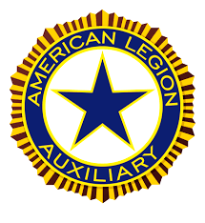

2025-2026
UNIT AWARDS MANUAL

American Legion Auxiliary
Department of West Virginia, Inc.
1251 Doolin Run Road
New Martinsville, WV 26155
1-304-398-2070
(e) department@wvaux.org

Department Web Site: www.wvaux.org

INTRODUCTION

This Manual will be a guide on Unit awards your Unit can apply for in all committees. This will be very important for your Unit to refer to all year long. PLEASE use it and hopefully your Unit will win many awards at the end of the year at the Department Convention. But the secret to it all is to REPORT all that you do: volunteer hours, cost of project, number of volunteers helping, number youth served, number veterans served, and do PUBLIC RELATIONS on everything that your Unit does— toot your horn — no one else will.

PLEASE give this information to Unit committees. It will be easier for them as some things have been changed due to the high cost of postage and material to distribute to the Units. PLEASE make the effort to keep the lines of communication open between your Unit, our Department Chairmen and this Office all year long.

Throughout the year, always remember the grass roots of why this organization is here and why we, the members, want to keep the purposes of this organization moving forward for many years to come.

MISSION STATEMENT

In the spirit of Service not Self, the mission of the American Legion Auxiliary is to support The American Legion and honor the sacrifice of those who serve by enhancing the lives of our veterans, military, and their families, both at home and abroad. For God and Country, we advocate for veterans, educate our citizens, mentor our youth, and promote patriotism, good citizenship, peace, and security.

National American Legion Auxiliary Web-Site: The National Program Engagement Plan is on the National Website (www.alaforveterans.org).

Here is how you can get into the National Programs Engagement Plan:
- Go to www.alaforveterans.org
- Once you are on the homepage, click on “Member Log In” and type in your name and password.
- When the member portal opens, click on the “Guides” tab at the top of the page, then click on “Programs Action Plan – Historic.”
- The Manual will come up and you can scroll/page through and find information on the program/committee that you want.
- Here you can read the Mission, Goals and Tactics of the committee you want to work on and
print this out or just write down what you want to know.

FORMS – APPLICATIONS – are available online on the Department website at www.wvaux.org. You can also go to the National website at www.alaforveterans.org. Click on Scholarship and you will find the scholarships listed there. Click on the one you are looking for and you can download the application(s) you need.

Forms can be found after completing the Member Log In. When the member portal opens, you can click on any of the tabs found at the top of the page or type in the search area what you are looking for.

AVAILABLE: Scholarship Forms Auxiliary Emergency Fund Application
American Essay Cover Sheet Youth Hero/Good Deed Award
Junior “Patch Program” forms

UNIT IMPACT REPORTING SHEET: It is enclosed so that your Unit can use it at your Unit meetings. Let each member take one home and keep track of their volunteer work from one meeting to the next. If they gave blood, volunteered for a blood drive, volunteered with a community event, helped out a veteran, helped out a neighbor, volunteered at library, school or church, made any donations, etc. this can be noted on the sheet. This will help your Unit on the end-of-year report since you will then have information from members on what they have done. All members should get credit for what they have done in the community, but they have to let the Unit know.

All Narratives sent to National MUST have a National Award Cover Sheet and be submitted electronically. It can be found on the National website along with the instructions.

Index

Americanism & Flag Alliance ------------------------------------------------------------------------------------ 11
Americanism Essay Cover Sheet ----------------------------------------------------------------------------------- 46
Auxiliary Emergency Fund ------------------------------------------------------------------------------------------ 12
Cash Awards ----------------------------------------------------------------------------------------------------------- 45
Chaplain ---------------------------------------------------------------------------------------------------------------- 7
Children & Youth ----------------------------------------------------------------------------------------------------- 13-15
Community Service --------------------------------------------------------------------------------------------------- 15
Constitution & Bylaws ----------------------------------------------------------------------------------------------- 16
Education --------------------------------------------------------------------------------------------------------------- 17
Finance ------------------------------------------------------------------------------------------------------------------ 18
Girls State --------------------------------------------------------------------------------------------------------------- 20
Historian ----------------------------------------------------------------------------------------------------------------- 8
History of the ALA (formerly Cavalcade of Memories --------------------------------------------------------- 11
Introduction ------------------------------------------------------------------------------------------------------------- 2
Judging ------------------------------------------------------------------------------------------------------------------ 5
Junior Activities ------------------------------------------------------------------------------------------------------- 21-23
Leadership -------------------------------------------------------------------------------------------------------------- 23-25
Legislative -------------------------------------------------------------------------------------------------------------- 26
Member Year-End Impact Form ------------------------------------------------------------------------------------- 47-49
Membership ------------------------------------------------------------------------------------------------------------ 26-28
Music -------------------------------------------------------------------------------------------------------------------- 28
National President’s Message ---------------------------------------------------------------------------------------- 6
National Forms ------------------------------------------------------------------------------------------------------- 3 & 45
National Security ------------------------------------------------------------------------------------------------------ 29
Past Presidents Parley ------------------------------------------------------------------------------------------------- 29-30
Poppy -------------------------------------------------------------------------------------------------------------------- 30-34
Public Relations -------------------------------------------------------------------------------------------------------- 36-38
Scrapbook --------------------------------------------------------------------------------------------------------------- 43
Standing Rules ------------------------------------------------------------------------------------------------------ 17
Total Participation ----------------------------------------------------------------------------------------------------- 44
Unit President Award ------------------------------------------------------------------------------------------------- 38
Unit Secretary ---------------------------------------------------------------------------------------------------------- 18
Unit Treasurer ---------------------------------------------------------------------------------------------------------- 19
Unit Year-End Impact Form ----------------------------------------------------------------------------------------- 49
Veterans Affairs & Rehabilitation----------------------------------------------------------------------------------- 39-42
Attention All Units

This awards booklet is posted on Department Website: www.wvaux.org

This booklet will be emailed/mailed to each Unit President/or Secretary. It is the responsibility of the Unit President to see that the information in this Awards Manual is distributed to all Unit Chairmen and Officers. The Department Chairman for each program is listed and can be contacted by your Unit or Unit Chairman if there are any questions about any phase of her program. Please don’t hesitate to contact Department Headquarters at 1-304-398-2070 or e-mail at department@wvaux.org
if any further information is needed.

All Traveling Plaques are plaques that are returned each year at the Department Convention to be awarded again. Extra forms, applications and pamphlets are available from National at www.alaforveterans.org, Department Headquarters website at www.wvaux.org or upon request at 1-304-398-2070 or 1251 Doolin Run Road, New Martinsville, WV 26155.

Attention Department Chairmen & Officers

This awards manual contains all the awards and contests pertaining to the Units with the deadline dates contests need to be sent to the Department. Please read your Committee section and know what awards and traveling plaques that you are responsible for at State Convention and on the National level. If there is a correction or change, let this office know so it can be sent to the Units in time for their entries.

PLEASE know your National Program Engagement Plan for the processing of Unit entries into National for judging. Don’t let this be a surprise to you in May or June. ALSO have your report and winners ready for the Department Convention for presentation. If you’re not able to attend the Department Convention, YOU MUST CONTACT President Kim Mellie or this office as soon as possible. Be aware of your duties and deadlines.

Judging

All Department traveling plaques and trophies are judged at Department Convention: all material, books etc. must be given to the Department Chairman at Department Convention by Thursday, July 10, 2026. ONLY -- If there is a conflict of interest in judging by that Department Committee Chairperson, then the Convention Judging Committee will be used for the purpose of judging. The Judging Committee is not there to judge all committee entrees; that is the responsibility of each Committee Chairperson.

You can get on the internet at www.alaforveterans.org if you would like more information or to get up-to-date on issues. You must sign in and go to “Resources” tab or type in the “Search” area that you’re looking for.

ALA NATIONAL PRESIDENT: PAM RAY
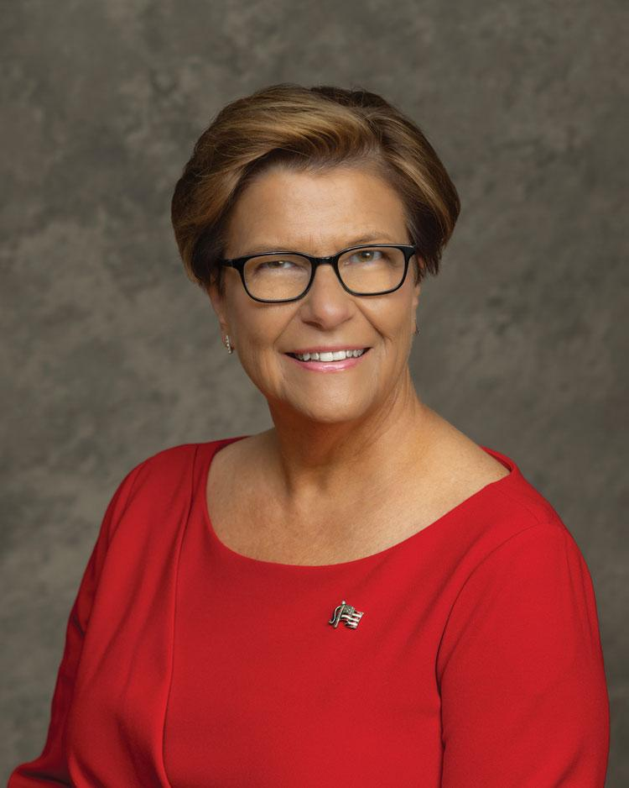

Pam Ray was elected national president of the American Legion Auxiliary (ALA) during the organization’s 104th National Convention held Aug. 23-29 in Tampa.
Department of Illinois: Urbana Unit 71
Eligibility: Through late father, Clay Lofton, who served during the Korean War and WWII.
Offices Held: Served numerous unit-, district-, and department-level offices and chairmanships. National: chair of Veterans Affairs & Rehabilitation, ALA Girls Nation, Junior Activities, National Security, Membership, Constitution & Bylaws, and Children & Youth committees. Served on the National Executive Committee and ALA Strategic Planning Committee; also served as vice chair of Americanism, Public Relations, and Junior Activities committees, as well as currently serving as American Legion Auxiliary national vice president.
Professional/personal background:Pam is a 69-year PUFL member of the American Legion Auxiliary Department of Illinois. When she was a pre-teen, her parents transferred her to Urbana Unit 71 so she could be an active Junior member. Pam never looked back. She has served in all Junior offices in her department, including Honorary Department Junior President in 1972. She continued her service in the ALA as an adult serving several offices in her unit, including president, historian, and sergeant-at-arms. She served as district president 2002-2003. On the department level, she also served several offices, including department president in 2010-2011. She was proud to serve with then-National President Carlene Ashworth as a Power of One girl!
Pam wanted to be a nurse from the young age of 3. She achieved that dream in 1977 and had a wonderful 47-year career. She loves caring for people who need her help. She has worked in the Burn Center, Pediatrics, Neurosurgery, and spent much of her career caring for head and neck cancer patients and their families.
Pam is married to Harl “Butch” Ray. They have been married for 46 years. Butch is retired from the Secretary of State’s office in Illinois serving as director of Physical Services. Butch and Pam have two daughters. The oldest daughter is Dr. Sara Helmus, an associate Dean of Students at Morton College and loves teaching so much that she still teaches a chemistry lecture class. Sara is married to Jonathan and they have a beautiful husky, Siko. Pam and Butch’s youngest daughter, Ami, is a master’s degree licensed counselor. She also works at a law firm as their office manager and paralegal. Ami has two wonderful children. Chloe is 14 and Ben is 11. They are definitely Butch and Pam’s pride and joy.
“I am so proud of my family. My parents are no longer on this earth, but I know they are cheering me on from up above as I take this step to serve the organization that they raised me in,” said Pam. “What an incredible honor this will be for me and my family.”
Pam’s passion has always been helping people. She has found that the ALA’s mission is a way to continue doing that. Her family is her other passion. What better way to bring the two together than with a theme of Mission Driven, Family Focused.
Chaplain

Rebecca Farley
chaplain@wvaux.org

RESPONSIBILITIES OF AN AMERICAN LEGION AUXILIARY CHAPLAIN
The chaplain should attend all meetings and have an opening and closing prayer at each meeting. These prayers may come from any source: Reflections in the quarterly Auxiliary magazine, www.ALAforVeterans.org, self-composed prayers, or those found elsewhere.

As a chaplain, the most important thing for you to remember is that the American Legion Auxiliary does not promote any one religion. We must not offend anyone by promoting our own religion.

Suggested activities:
Reporting the names of members who are ill and sending them cards
Sending sympathy cards to family members. If possible, visit the funeral and hold a memorial service for the deceased member.
Being in charge of religious services for the unit.
Visiting members and veterans in nursing homes or those who are shut-ins.
Keeping in contact with Gold Star Families and remembering them on holidays.
Volunteering at community projects.
Making a prayer book or devotional book. In doing this, encourage member participation.
Ceremonies may be found in the Manual of Ceremonies of American Legion Auxiliary

Unit Prayer Book: Senior Prayer Book Best overall 10 - 150 Cash Award
Senior Prayer Book Best overall 151 and over Cash Award

Unit prayer books can be any size, consist of as many prayers as you desire and designed any way the Unit wishes. You may list the prayers in any order you want (by month, by programs, by events, etc.). This can be submitted by any senior member. Prayer books need to be brought to the Department Convention by Thursday, July 10, 2026 by 9:00 pm to qualify for judging. Make sure your name & address, Unit Name & number are listed.

The Department President’s Prayer Book. Any Unit or District Chaplain or Unit member may submit a prayer, poem, or spiritual verse to the Department Chaplain for the prayer book. Those that are turned in will also be forwarded to the National Chaplain for her use in the National President’s Prayer Book. They must reach the Department Chaplain by April 15, 2026 to be compiled into a large Prayer Book to be presented to our Department President at the Department Convention.

Department Chaplain Plaques:
Patricia Moore Plaque Membership 10 - 150
Susan Wade Plaque Membership 151 and over

Unit Prayer Book Traveling Plaque: Dortha Parsons 1st Place Best overall Prayer Book

Historian

Holly Adams
historian@wvaux.org

Responsibilities of an American Legion Auxiliary Historian:
The recording of the American Legion Auxiliary’s history at all levels (unit, district/county/council, department, and national) is important so that everyone will know who we are, what we do, and why we matter. Other responsibilities of a historian are:

Assist in developing a system to archive important communications such as newsletters, handbooks, guidebooks, brochures, and program information
Participate in and promote the “Members Remember” history project
Work with the Junior Activities chairman to promote the History Patch available to Junior members in 9th – 12th grades.
Encourage Senior and Junior historians to participate in the Veterans History Project

Important Dates:
March – National Women’s History Month
May 15 – Annual reports due to the National Historian
July 9 – Senior and Junior Department histories are to be submitted to your respective National Division Vice President

National Historian Program Awards
Best Department Senior History
Best Department Junior History
Certificate presented to each department Senior historian who forwards a copy of a veteran’s history using the Veterans History Project
Certificate presented to each department Senior historian who participates in the “Member’s Remember” history project
Certificate presented to each department Junior historian who forwards a copy of veteran’s history using the Veterans History Project
Certificate presented to each department Junior historian who helps Senior members record their Auxiliary memories for the “Member’s Remember” history project

Rules for Senior History:
I. Introduction (10 points)
1. Title Page
a. History of Unit ______________________Number________________

b. Name of Unit Historian______________________________________
c. Date: 2025-2026
2. Forward or Dedication
3. Unit President’s Picture, black and white, or color (optional—if used 5x7)
or name. If using pictures, please put the name of the President under
the picture. All shall be centered and in the middle of the page.
4. Prayer
5. Pledge of Allegiance to the Flag of the United States of America
6. National Anthem — First Verse of “The Star Spangled Banner”
7. Preamble to the Constitution of American Legion Auxiliary
II. Historical Content (70 points)

1 .List of Unit Officers for 2025-2026
- Elected Unit Officers for 2025-2026
- bAppointed Unit Officers for 2025-2026
2. List of Unit Chairmen for 2025-2026
3. List of Department Officers and Committee appointments held by
members of your Unit for 2025-2026.
4. List of National Officers and Committee Appointments held by members
of your Unit for 2025-2026
5. A list of Unit Awards received at the 2025 Department Convention
6. A list of Unit Awards received at the 2025 National Convention
7. The history shall be written as a FACTUAL NARRATIVE beginning with the installation of officers and ending with the month of June.
8. The signature of the Unit historian is to immediately follow the final paragraph of the History.
9. Index (optional)
III. Appearance (10 points)
- Cover: Soft cover binder for loose leaf paper, preferable blue, with 2 ½ inch gold foil American Legion Auxiliary seal centered on the cover or a regulation binder with imprinted seal. (These are available from Emblem Sales or Department Headquarters)
- Paper: 8 ½ x 11 inches, plain white
- Margins: left and right margin should be 1.25 in.; leave one inch from top and bottom of the page.
- Page numbers should begin on the first page of the Historical Content. They should be centered and placed 0.5 inch from the bottom of the page.
- Spacing: double-spaced with the exception of the introductory pages (Title page, Foreword or Dedication, photograph of Unit President, Prayer, and Pledge of Allegiance to the Flag of the United States, first verse of “The Star Spangled Banner” and Preamble to the Constitution of the American Legion Auxiliary) which shall be centered in middle of the page. Paragraphs may be indented or in block form.
- Text: 12 point font, Times New Roman or Arial style font
- Technology: Computer preferred, however, a typewritten or handwritten history is permissible. If typewritten or handwritten, the page set should not vary from what is required of computer users.
IV. Arrangement (10 points):
- Written in third person
- Clear concise language with correct spelling
- No decorations, computer graphics, pen or ink drawings, illustrations, extra material, or newspaper clippings. Be original and unique in thought and presentation.
V. Deadline: Unit Histories must be submitted to the Department Historian at the Department Convention by Thursday July 9, 2026, by 9:00 pm to be qualified for judging.

Deadline for Department History information: Must be to Department Historian by April 15, 2026.
All Department Officers and Chairmen must compile an end-of-year narrative report on their committee from information on Unit Year-End Impact form. All District Presidents will need to compile an end-of-year narrative report from all the Unit Reports and activities given at Spring Conference. District Vice Presidents can submit a small narrative membership report of your District for the year to the Historian.

Unit Awards: Senior History Membership 10 – 150 cash award
Senior History Membership 151 and over cash award

Department History Plaques:
Janet Culp Plaque Membership 10 - 150 Best Overall History Report
Roxie Nicholson Plaque Membership 151 and over Best Overall History Report
Tiffany Sine Junior Plaque Best Junior History Book

Veterans History Project—National strongly recommended that members participate in the Veteran’s History Project. More information on this program is at www.loc.gov/vets/kit.html
  - Work with the Junior Activities Chairman to promote the Veterans History Project through Facebook, e-mails and during meetings.
  - Stress the importance of collecting the history and the case of participating in the project through all communications.
  - Highlight details of the project on the National Historian’s webpage.
  - Letter from National President and National Historian presented to one Junior member in each division who submits the best (250-word minimum) essay of why she chose to participate in the Veteran’s History Project.

Americanism & Flag Alliance

Sandra Harper
americanism@wvaux.org

Knowledgeable on US Flag history, etiquette, and proper disposal methods, and promote the observation of patriotic holidays so your community will look to the ALA.
* Promote Americanism in the community
* Promote Get Out The Vote
* Educate our youth on the History of the United States such as – Patriotism and The U.S. Constitution
* Promoting Star-Spangled Kids
* Promote the Americanism Essay Contest
* Support American Legion Baseball
* Support the Oratorical Contest
* Support Junior Shooting Sports
* Promote Citizens Flag Alliance

Together we are the “Mighty ALA”
Americanism Key Resources
Available online at www.legion-aux.org
* Americanism Essay Contest Cover Sheet
* Americanism Essay Contest Deadline Flow Chart
* How to promote Star-Spangled Kids
* Let’s Be Right on Flag Etiquette
* The American Legion’s Flag Advocacy
* Citizens Flag Alliance
* The American Legion’s Action Programs of Americanism
* ALA’s Americanism Facebook Group
* Wreaths Across America Educational Resources
* Much more available.
Americanism Essay Contest

Help increase participation in the Americanism Essay Contest.

The Americanism Essay Contest topic for 2025-2026: :“Celebrating America’s 250th Birthday and the Veterans who Fought for Our Freedom.”
* Encourage Junior members and family members to participate in the essay contest.
* Work with school administration to identify guidance counselors and English and History teachers whose students would be interested in participating.
* Contact youth organizations to identify potential youth for participation in the contest.
* Provide all interested students with information packets explaining contest rules, deadlines, topics, and award opportunities.
* For details on the Americanism Essay Contest, visit https://www.legion-aux.org/americanism-essay-contest.
Awards:
National Unit Award: Most Outstanding Unit Americanism Program (per division)—submitted by 5 p.m. ET on June 1, 2026.

Department Awards: A Department Plaque presented to the Unit with the best overall end-of-year report. The report must be to the Department by April 15, 2026. First Place Sally Arcuri Plaque
Second Place June Harbert Plaque

Auxiliary Emergency Fund

Melanie Shambaugh
aef@wvaux.org

Overview:
The Auxiliary Emergency fund was established in 1969 by the National Executive Committee as National President Marcella Davidson, Department of New Mexico, started this as her special project. It was funded initially through a generous legacy gift from Auxiliary member Helen Colby Small of Burlington, Wisconsin. The AEF is now able to continue to grant temporary financial assistance through voluntary contributions to those auxiliary members who have suffered a financial setback.
The Auxiliary Emergency Fund may provide eligible members with temporary financial assistance during times of financial crisis or weather-related emergencies and natural disasters.
In 1981, the Auxiliary Emergency Fund was expanded to include a fund to help members who needed to support themselves due to unexpected life-changing circumstances such as death or illness of a spouse, divorce, or desertion. The women in those situations found it difficult to obtain employment and some were without the job skills necessary to obtain adequate employment. Because of this, short-term assistance can now be provided to help our members acquire marketable job skills through schooling or job training when all other sources of financial aid have been exhausted.
Eligibility: Any member of the American Legion Auxiliary who has maintained membership for at least the immediate past two years and has paid their dues for the current year (three consecutive years of membership).
Amount: The maximum amount of any grant is $3000.00 and may be disbursed as determined by the Grant Committee. Payments may be made directly to the member, or at the discretion of the Grant Committee, to the mortgage company or utility company. In the case of educational grants, payments may be made directly to the educational institution.
How to Apply: Applications can be obtained from your Department Secretary, Department Chairman or Unit Chairman or found online at www.ALAforVeterans.org
How to Promote and Support the Auxiliary Emergency Fund: Each Unit should appoint a Unit AEF Chairman whose responsibility it is to creatively publicize the program and to educate the unit members regarding the availability of the fund in a time of need.
Units should support the AEF by raising funds as grants are made possible through the generous contributions of members helping members. Financial gifts may be donated by Departments, Units, or Individuals. Perpetual Memorials may also be established in the name of a family member or special Auxiliary member. All contributions to the AEF are tax-deductible.
Deadline Dates to Remember:
Year-End Report: April 15, 2026
Department Award Largest Contribution Deadline: May 31, 2026
Unit Contributing the Largest Amount (per capita) Deadline: May 31, 2065
Department Contributing the Largest Amount (per capita) Deadline: May 31, 2026
Children & Youth

Beth Kilgore
childrenandyouth@wvaux.org

The Children & Youth program emphasizes protecting, caring for, and supporting children and youth, particularly those of veterans and military families.
- Work with your post to organize celebrations for the youth in your community. Host an Easter egg hunt, a Christmas party, a Halloween party or a family movie night, etc.
- Donate coloring books to schools---three ALA Coloring books can be purchased from American Legion Emblem Sales
  - Have a Safe Halloween
  - America the Beautiful
  - ALA Poppy Coloring Book
- Contact your local churches, homeless shelters, and food pantries to identify homeless veterans’ children. Ask what their specific needs are and offer them your services as an ALA member.
- Consider donating Children’s movies, coloring books and crayons, toys, etc. to a homeless shelter.
- Some of our homeless veterans have children living on the streets with them.

The American Legion Auxiliary Children & Youth program strives to support and promote the Children & Youth program of The American Legion.
- Work with your post to cross promote youth programs. Invite Legionnaires to speak at a Unit meeting about Legions Boys State, Legion Baseball, Oratorical Contest, etc. Speak at a post meeting about ALA Girls State, Junior Activities, etc.
- Partner with local organizations, such as Boys and Girls Club, to advance programs for military children and other youth.

To recognize and reward the positive actions of our children and youth, the American Legion Auxiliary has two special national awards bestowed to youth nominated by Units: Youth Hero Award and the Good Deed Award.
- Watch your socials and local media for possible nominations of students.
- Use the online form to submit your nomination.
- Invite your winners to a Unit meeting to present the award to them.
- Contact your local media and submit a press release regarding the award presentation.
- These awards are presented annually throughout the year to recognize the heroism and helpfulness of youths under age 18.
- Nominations are made by local ALA Units. If you know of a youth deserving of one of these awards, submit a nomination.
- Nominations may be submitted directly on the national website: More information: https://member.legion-aux.org/youth-hero-good-deed-awards.

Good Deed Award
Youth should demonstrate a leadership role in community service.
- A specific deed should be present: donates time and/or raises money for worthy cause (raises money for homeless veterans, food drive, monument, etc.)
- Junior American Legion Auxiliary members may be nominated for the award.
- Winners receive a medal and certificate.

Kids of Deployed are Heroes 2 (KDH2) is an initiative honoring military children who may be experiencing a separation from one or both patents, whether deployed to a war zone, having a short tour, or on an extended temporary duty assignment.
- Volunteer at a Family Readiness Group event where KDH2 “I’m a Hero 2” buttons/stickers can be distributed.
- Host a KDH2 celebration with recognition buttons/stickers to let military kids know we appreciate their sacrifices.
- More Information: https://member.legion-aux.org/member/committees/children-and-youth/recognize-kids-of-active-military

The American Legion Auxiliary supports Military Kids
- Wear purple April 15 in honor of Purple Up! Day for Military Kids.
- Perform the Military Child Table ceremony at a Unit meeting or in your community.
- Contact your local news sources (newspaper, community television, community websites, and social media accounts) and town council with an offer to give a presentation about you and your Unit’s work for veterans and military children.
- Plan a special celebration for children during the month of April in honor of Children & Youth Month and Month of the Military Child.
- Host a dinner, game night, or community fair, etc., that will bring military and non-military families together.
- Conduct a community project with and for children.

The American Legion Child Welfare Foundation was formed to provide assistance to nonprofit organization to educate the public about the need for the care and welfare of our nation’s children.
- Members of the American Legion Family are the prime contributors to the success and growth of ALCWF.
- Units may collect donations at meetings or other events.

Support Children of West Virginia by meeting your reporting deadlines.
- Year-end reports are annual reports reflecting the program work of our Units and may result in Department and National awards for participants who meet the requirements.
- To reflect the work of your Unit, it is important that details of activities are recorded after each project.
- A Unit Activities Report Form helps Unit chairmen keep accurate records of volunteer hours and money spent by the Unit or individual members for activities.

Unit Activities Report Form (modify spacing for your own needs)

Committee ________________________________________________________________________________

Name __________________________________________ Date _____________________________________

Description of activity _______________________________________________________________________

How much was spent by Unit for this activity? _______________

Value of items donated _____________

Description of goods or items donated __________________________________________________________

Number of children, people benefitting or served _______________

Names of American Legion Auxiliary members participating in the activity and hours volunteered __________

__________________________________________________________________________________________

__________________________________________________________________________________________

ALA Committee Facebook Groups are spaces on the social media network for ALA members to discuss or share about how broad or narrow topics to each committee. Groups provide an arena for organize discussion about your local programs or services and present the opportunity to cultivate brand awareness.

This is a place to share activities and events, ask questions, obtain information and promote Children & Youth Activities: https://www.facebook.com/groups/ALAChildrenYouth/

April is Children and Youth Month: Plan a special celebration of children.
April is the Month of the Military Children
April 15th is Purple Up! For Military Kids Day: wear purple to honor them!

Department Children and Youth Plaques: Department plaque to the Unit with the best overall end-of-year report emailed by April 15, 2026.
First Place Shirley Davis Plaque
Second Place Irene Weber Plaque

Community Service

Kelli Immel
communityservice@wvaux.org

The Community Service program promotes the American Legion Auxiliary’s visibility within our localities through our commitment to community, state, and nation.

What can you do? Become visible within your community as a link to the veteran community. Get involved in community service projects to bring awareness of our mission to support veterans, service members, their families and the community. Members – always wear your American Legion Auxiliary apparel or pin while volunteering in the community; it reinforces our brand promise by telling people who we are, what we do, and why we matter.

Reach out to local ministers and first responders to indicate your willingness to be a designated responder for veteran families in need. Be sure to keep a list of veteran resources handy so you will be ready. Get involved with your neighbors and those outside our Legion family by volunteering at your local library, food pantry, domestic violence shelter, senior citizens centers, assisted living centers, and nursing homes. Represent the Auxiliary as a member of local community boards and committees. Volunteer with your local Meals on Wheels to deliver meals on days when they are typically closed (i.e. Christmas and Thanksgiving). Volunteer to organize or assist with your community’s Veterans Day observance. Organize and participate in service projects for veterans, service members, their families and local community programs on ALA suggested days of service. Register service projects on websites, community forums, and social media to attract other community members to participate in your service projects. Volunteer for local service projects and causes (walks, special events, etc.). Work with your post home to offer space and their participation in local service projects and causes. Sponsor and participate in activities at local libraries, senior citizen centers, assisted living centers, nursing homes, service projects and causes (walks, special events, etc.). Attend and represent the Auxiliary at special celebration events in the community such as holiday parades, grand openings of community facilities and community leader recognition ceremonies.

National Awards
Community Service Unit Award
Best Department Community Service Program Award

Department Community Service Plaques: Department award to the Unit with the best overall End-of-Year report, emailed by April 15, 2026.
Mary Ann Piatt Plaque Membership 10 - 150
Imogene Kirkland Plaque Membership 151 and over

Constitution & Bylaws

Chair: Michelle Powell Peggy Swartz Mary Spence
constitution@wvaux.org 304-800-3060 304-887-7187

Governing Documents are the laws of the organization. They are legal and binding documents.

Objective:
- Inform and educate members of the importance and power of having properly written and regularly reviewed and updated governing documents of the organization.
- Governing documents are Constitution, Bylaws, Standing Rules, Incorporation, and Policies.
- Governing documents state details on how the membership agrees to govern itself, for example but not limited to, how to choose its leasers/officers/delegates, when, where and how often to hold meetings, executive committee and officer rules and amendments.
- Know the non-profit laws.
- Put in place rules that allow operations to continue in an emergency.
- Include rules so important that they cannot be changed without previous notice.
- Keep governing documents up to date and available to all members.
- Governing documents cannot be in conflict with District, Department or National’s governing documents.
- When the National, Department or District constitution and bylaws change, Units should automatically update their governing documents.

Key Resources:
- Your District’s Constitution & Bylaws of American Legion Auxiliary, ask your District President for a copy.
- Department Constitution & Bylaws of American Legion Auxiliary, back of directory or online at www.wvaux.org
- National Constitution & Bylaws of American Legion Auxiliary, online at www.alaforveterans.org or order from Emblem Sales
- Unit Guide Book, online at www.alaforveterans.org or order from Emblem Sales. Shows structure and examples.
- Robert’s Rules of Order Newly Revised, Emblem Sales or book stores
- Registered Parliamentarian, The National Association of Parliamentarians is a good resource to find a professional registered parliamentarian near you.
- Basic Parliamentary Procedure

Standing Rules

Wendy Miller, Chair Tiffany Orlando Cindy Gadd standingrules@wvaux.org 304-820-5774 330-831-6214

Objective: Standing Rules
--relate to the details of administration of the organization
--may be adopted by a majority vote
--may be amended or rescinded

Department Standing Rules are in the back of the Department Directory and online at www.wvaux.org.
National Standing Rules are available online at www.alaforveterans.org or order from Emblem Sales.

Education

Lisa Harbour Carla Wilfong Sharon Duckworth
education@wvaux.org 304-592-0247 304-216-5511

Purpose: The purpose of the Education Committee is to promote quality education for children, especially for military children and adults.

Description: For the payment of tuition and necessary fees only – not to exceed $500.00 per academic year. It must be renewed annually with letter of enrollment and not to exceed a total of four awards – or a total of $2,000.00.

Eligibility:
Applicant must be a son, daughter, grandson, or granddaughter of a Veteran.
Applicant must be a resident of West Virginia under 22 years of age when applying for first grant.
Applicant must be a high school graduate or in graduating class when applying.
Applicant must demonstrate financial need in order to qualify.
Applicant must achieve qualifying score on Scholastic Aptitude Test for the College Entrance Examination Board of West Virginia Colleges except if the applicant wishes to pursue some other career such as Beauty Culture, Nursing, etc.
Must have 16 credits of A, B, or C grades in last five (5) semesters of high school and must maintain a “C” average to be considered for renewal of grant. Copies of grade transcripts must be submitted to Department Scholarship Chairman each year to be considered for renewal.

Application Procedure

- Application must be submitted prior to March 1, 2026 to Unit President or Unit Scholarship Chairman for thorough investigation as to actual financial need before being presented to the Department Education Chairman for consideration.
- Must have a certified transcript or photocopy of the applicant’s high school grades.
- Must be prepared to submit a Parent’s Confidential Financial Statement as evidence of financial need.
- Must present a letter of acceptance to a college or university of your choice in state of West Virginia ONLY!
- Must have a copy of ACT or SAT test Scores.
- Must provide a brief statement of the military service of parent (parents) or grandparents including the branch of service and dates of service and a photocopy of veteran’s DD214 or other proof of military service.

Department Education Plaques: Department plaque to the Unit with the best overall End-of-Year report emailed by April 15, 2026.
Janet Durbin Plaque Membership 10 - 150
Virginia Beaty Plaque Membership 151 and over
Finance

Ann Buchanan, PDP Stephanie Handley Lynda Lancaster-Lloyd
finance@wvaux.org 304-670-4055 304-676-3979

Mission: The responsibility of the Department Finance Committee is to oversee the general financial policy of the Department, subject to the ratification of the Department Executive Committee, and preparation of the Annual budget and supervision of the expenditures under that budget.

Finance is the key ingredient that creates the ability for the organization to provide services to veterans and their families on all levels (Unit, Department, and National). Every member is an investor and needs to be an informed investor.

All Units should have their financial records audited at least once a year. There should be financial report at each Unit meeting – not just a balance in an account. Members that attend should know what is coming in and what is being spent. A copy should to be given to Unit Secretary to be attached to that month’s minutes.

All members that handle money in Unit are covered on the National Blanket Bond that the Unit pays annually ($5.00). Each Unit is required to complete the IRS Form 990N prior to the annual deadline which is based on the Unit’s fiscal year.

Unit Secretary

It is your or your President’s responsibility to keep the Unit informed of what is happening in the Department and District. The Department Newsletter (The Auxiliary Spirit) should be taken to Unit meetings and shared with your members. Encourage your new members to be involved with your Unit projects, events and fund-raisers. Strive for the future of your Unit. Please note the information and material that needs immediate action in Department mailings. These are very important mailings for your Unit.

Be prompt in returning all dated material. It must all be in on time for Headquarters to meet deadlines with National and to get material out to the Units in time for their use. If everyone works together on the deadline dates, then things will get done in a timely manner. All events and hard work of your Unit will get counted, no matter how small you may think it is.

Unit Treasurer

Make all checks payable to Department Treasurer, ALA. Designate on each check the purpose for which the money is intended. Membership must be on a separate check. Other donations can be in one check, but list what each donation is for and the amount. Unit account ledgers should be audited each year.

Keep funds in two separate accounts or two separate ledgers - General Fund and Welfare Fund (Poppy Fund).

GENERAL FUND - deposit all membership dues, money from fund-raisers and any donations received for the Unit. All money EXCEPT Poppy proceeds go in the General Fund. Disbursements from the General Fund are Unit expenses, ordering material from National or Department Headquarters, or any cost of fund-raisers.

GENERAL MANDATORY FUNDS - MUST BE PAID BY JUNE 10, 2026.
Bonding ($5.00)
Department Scholarship Fund- donation of your choice
Girls State Project- donation of your choice

WELFARE FUND - deposit all proceeds from Poppy Day collections. Disbursements that can come from Welfare Fund (Poppy Fund) are Gift Shops at the four VAMC (Beckley, Clarksburg, Huntington, & Martinsburg), Cheer parties (monthly and are held at the five hospitals in WV {Beckley, Clarksburg, Huntington, Martinsburg, and WV Veterans Home}). Poppy Funds can be used for the Honor Flights and also Essential items for Guard and Reserve..

WELFARE MANDATORY FUNDS - MUST BE PAID BY JUNE 10, 2026.
Veterans 1st Fund
10% Poppy Proceeds

Purchasing poppies are not mandatory to be eligible for Membership Awards. Poppies are 20 cents each and can be ordered in any amount. The order form for Poppies will be on the Department website.

Have your Treasurer’s Books audited yearly. The Audit Report will show the Unit that all canceled checks, check book, ledgers and bank accounts are in order for the new year. The Audit Report must be signed by the Audit Committee.

All donations to National need to be made by April 15, 2025 and reported on your Unit Year-End Report.

DONATIONS TO NATIONAL

Make check payable to: National Treasurer, ALA
Mail to: National American Legion Auxiliary
3450 Founders Rd.
Indianapolis IN 46268

DONATIONS TO DEPARTMENT

Make check payable to: Department Treasurer, ALA
Mail to: Department American Legion Auxiliary
1251 Doolin Run Rd
New Martinsville, WV 26155

Mandatory Funds Gift Shops
Auxiliary Emergency Fund Cheer Parties
Spirit of Youth
Department President’s Special Project History of The American Legion Auxiliary
National President’s Project (Cavalcade of Memories)

DONATIONS TO AMERICAN LEGION
Make check payable to: The American Legion, National Treasurer

National Child Welfare Foundation Comfort Warriors
The American Legion The American Legion
P O Box 1055 PO Box 1055
Indianapolis IN 46204 Indianapolis IN 46204
DONATIONS TO: (Make checks payable directly to the following)

USO
P O Box 96860
Washington DC 20077-7677

CHAPEL OF FOUR CHAPLAINS MAKE-A-WISH FOUNDATION
1201 Constitution Avenue 1000 DuPont Road Box 7
The Navy Yard Bldg. 649 Morgantown WV 26505
Philadelphia PA 19112
CHILDREN’S MIRACLE NETWORK
WVU Children’s Hospital
PO Box 8227
Morgantown WV 26506
HABITAT FOR HUMANITY
CHILDREN’S HEART LINK 322 West Lamar Street
5075 Arcadia Avenue Americus GA 31709-3543
Minneapolis MN 55436

FREEDOMS FOUNDATION FISHER HOUSE FOUNDATION, INC.
P O Box 67 12300 Twinbrook Pkwy Suite 410
Valley Forge PA 19481 Rockville MD 20852

Rhododendron Girls State

Lynda Lancaster-Loyd, PNCDVP, PDP/Co-chair Rosemary Thomas, Girls State Director/Co-Chair
girlsstate@wvaux.org

- The American Legion Auxiliary Girls State program is a marquee program of the American Legion Auxiliary that has been preparing female high school students for civic leadership since 1937. Through a weeklong “simulated government” immersive learning experience, America’s future leaders assume roles in the fictional “Nationalist” and “Federalist” political parties, run for and hold offices that mirror West Virginia’s State elective offices, and in one jam-packed week learn fundamentals about the legislative process, the three branches of government, and parliamentary procedure.
- In all 50 states, the American Legion Auxiliary proudly hosts ALA Girls State, an amazing week of learning focused on responsible citizenship and love for God and country.
- ALA Girls State delegates are a diverse group of young women with a shared desire to learn and lead. ALA Girls State “Citizens” come together from small towns, big cities, and rural areas to hold A:A Girls State Elections, and their varied backgrounds set the stage for a week of spirited, experiential learning.
- The American Legion Auxiliary Girls Nation is an once-in-a-lifetime opportunity for young women. The weeklong event gives participants a firsthand experience with practical insight into how the federal government works.
- ALA Girls Nation connects participants with their peers from across the country, allowing the young women a unique opportunity to spend time with others who share common interests and those who have different perspectives from their own. The girls leave Washington, D.C. with a deeper understanding of government, a renewed sense of patriotism, and an appreciation for veterans.

Department Plaques: Unit with the best report of Girls State activities by a Unit. This is to be judged by the Rhododendron Girls State Director. This report must be sent to the Department Headquarters by April 15, 2026.
Ann Buchanan Membership 10 - 150
Lillian Luttrell Membership 151 and over

Betty Rea Plaque: Unit with the best overall scrapbook that reports the Girls State activities by a Unit. This is to be judged by the Girls State Chairman. The Scrapbook must be at the Department Convention by 9:00 pm Thursday, July 10, 2025 for judging.

Samsung American Legion Scholarship: Girls State citizens will be able to apply for financial assistance when seeking a higher education. Applicants must be a High School junior who is a direct descendant, i.e., child, grandchild, great-grandchild or a legally adopted child of a United States wartime veteran. A selection criterion includes academic record, community involvement, school activities, and financial need. Applications are online once again this year. Application must be completed and hard copy turned in at registration at Girls State on June 7, 2025 at Davis & Elkins College.

Web Sites: www.alaforveterans.org and www.wvgirlsstate.org
Junior Activities

Patsy Greiner
juniors@wvaux.org
.
The Junior Activities Program inspires active participation in members 17 years old and younger so that they will become engaging, productive members who will want to continue their American Legion Auxiliary membership into adulthood. The mission of the Juniors Activities committee is to promote volunteerism through community-based programs and services that involve veterans and to teach the principles of loyalty to God and County, Justice, Freedom, and Democracy to our young members. Build your Junior Program 1 Junior at a time and give them the opportunity to participate. We will never make the next 100 years if we don’t put our Juniors first.

T -- Together T -- Teach
E -- Everyone E -- Encourage
A -- Achieves A -- Accept and
M -- More M -- Mentor our Juniors

National Awards
Patch Program: This gives Juniors the opportunity to increase their knowledge of patriotism, citizenship, leadership, health and fitness. There are different age levels of activities to complete in 11 categories. Each category completed earns a Patch. When these sheets are completed and initialed by the Unit Chairman or Unit President, send them to the Department Junior Activities Chairman. The patches will then be ordered from National. For more information on the following National Awards, please go to junioractivities@alaforveterans.org

Junior Member of the Year
Most Outstanding Unit Junior Activities Program (per division)
Best Department Junior Activities Program (per division)
Best Media Coverage of Activity or Project

The deadline for Unit Year-End Junior Activity Reports EMAILED to Department Juniors Activities Chairman is April 15,, 2026.

All Junior awards shall be judged by the Junior Activities Chairman unless her home Unit submits a report or for any reason that may cause a conflict. In either case, the report will be sent to the Department Judging Committee.

Department Awards
Cash Awards:
Membership – Most NEW Junior members in a Unit (award given by Membership Team)
Best Junior History (award given by Historian)
Best Junior Scrapbook (award given by Scrapbook Committee)

Traveling Plaques
All plaques are given at the Department Convention and are to be returned at the following year’s Department Convention. All engraving of plates for plaques is the responsibility of the receiving Unit. All are presented by the Junior Activities Chairman.
Kati Hart Department Honorary Junior President: presented to the Newly Elected Department Honorary Junior President
Best Overall End-Of-Year Report: Betty Shumate Membership 10-150
Margaret Kercheval Membership 151 and over
Best Junior History: Tiffany Sine
Junior Member of the Year Award: (sponsored by PDP’s Debbie Fox, Unit #60 and Lisa Cadwallader, Unit #71)

Criteria: (Deadline for National June 20, 2025)
- Presented to 1 Junior member in recognition for her dedicated service, efforts and talents.
- Consideration of only Junior members in good standing for the current year.
- Outstanding contribution the Junior has made through an ALA program or project.
- Length of membership is not a criterion.
- Name, email address (if Junior is at the age of having email) and complete mailing address must accompany nomination.
- A narrative or typed essay not to exceed 500 words summarizing the nominee’s accomplishments during the current administrative year.
- Please include pictures, clippings, scrapbooks, folders, etc. Send either electronically or via postal mail, nomination must be signed by the candidate’s Junior Activities Advisor and Unit President.
- The winning entry may be submitted to National.
- On the National Report and Award Cover Sheet, include the name and contact information of the Department Juniors Activities Chairman.

West Virginia Junior Member of the Year Traveling Plaque
- Entries must be typed and include the following information:
- Consideration of only Junior members in good standing for the current year.
- Outstanding contribution the Junior has made through an ALA program or project.
- Length of membership is not a criterion.
- Name, email address, and complete mailing address of nominee or parent must accompany nomination.
- A narrative, typed essay not to exceed 500 words summarizing the nominee’s accomplishments during the current administrative year.
- A cover sheet must be included with the name and contact information of the Unit Junior Activities Chairman.
- Please include pictures, clippings, scrapbooks, folders, etc. Send either electronically or via postal mail. Nomination must be signed by the candidate’s Unit Junior Activities Chairman and Unit President.
Winning Entry must be then submitted to National with a National Award Cover Sheet.
- On the National Report and Cover Sheet, include the name and contact information of the Department Junior Activities Chairman.

Department West Virginia Junior Member of the Year Traveling Plaque will work the same as all other Department traveling plaques.
- This will be selected and judged by the Department Junior Activities Chairman provided their Unit has not submitted an applicant and they are not related to any of the Juniors submitted, even if from a different Unit, otherwise it goes to the judging committee.
- The plaque will be awarded during the Department Convention on Friday or Saturday when the plaques are awarded from the Junior Activities Chairman.
- The winner will take the plaque, have it engraved with her name and Unit, and keep it for the year to return it at next year’s Department Convention.
This award was donated by Debbie Fox, Unit #60, and Lisa Cadwallader, Unit #71. Please contact them when it is time to replace it.

COMMITTEES or PROGRAMS that the Juniors can actively participate in:
Fold a Flag for Americanism
Collect for AEF – Auxiliary Emergency Fund
Make a scrapbook for Cavalcade of Memories
Say or write a prayer under the Chaplain
Help with Children & Youth events
Perform Community Service in your neighborhood
Help write or update your Constitution & Bylaws
Read to young children or donate 10 for Education
Donate to or assist with ALA Girls State
Interview a Veteran or a Charter member for History
Earn and participate in the ALA Junior Patch Program
Run for Honorary Junior Officer in your Unit, District or Department for Leadership
Write to a mayor or Community leader (Congressman) for Legislative
Recruit and have a friend join for Membership
Send care package to an active duty Service member for National Security
Assist female Veterans for Past Presidents Parley
Distribute Poppies or help on Poppy day
Learn Protocol and memorize the ALA Preamble
Write a press release or make a video for Public Relations
Volunteer at a VA Facility for VA&R
Assist your Unit with dinners, events, & activities
Help raise money for President’s special project (Veterans Affairs Christmas Gift Shops)

IDEAS
Remember…You can start with one member
- Nursing home to hospital visits
- Making or signing cards
- Crafts/snacks/cards for Veterans at a nursing home
- Crafts/decoration for your post
- Cards/packages to deployed military
- Helping Post/Auxiliary/SAL when needed
- Patch Program
- Junior Leadership Course
- History of the ALA/Legion/SAL
- Flag etiquette and proper salute to the flag
- Invite friends of Junior Members to attend functions and Volunteer, even if they are not eligible to join.
- Promote what they do. Put in the newspaper and on Facebook. With that being said, please make sure we have all of the paperwork filled out for pictures and names to be posted on FB and also the newspaper and emergency information sheets turned into the Unit and the Department Junior Activities people.

Leadership

Rebecca Farley
leadership@wvaux.org

Leadership Program Statement

The American Legion Auxiliary Leadership Program helps develop and prepare knowledgeable and capable leaders to carry on the growth and success of the Auxiliary by promoting activities and resources that educate, motivate, and mentor members of all ages and at all levels within the organization.

The American Legion Auxiliary is an organization that provides members of all ages, both Junior and Senior, the opportunity to develop and improve their leadership skills. Our organization depends on an ever-emerging stream of competent new leaders, trained and guided by experienced ones, to assume leadership within the Auxiliary and advance its mission into the next 100 years.

The Auxiliary offers a variety of opportunities for members to serve in various leadership positions… from chairing a short-term community service project at the local Unit level to running for national office.

Here in West Virginia:

We are working on leadership development programs. We will be given opportunities to be the best we can be…to display thoughtfulness, courage, strength and compassion.

We may also face obstacles, but we must remember it is within each of us to lead and to follow. We must take time to think through situations and ask ourselves what is the best way forward for the Auxiliary.

Leadership is a privilege as well as a responsibility. Let’s take this time to travel this road together, learn from one another, and put into action that which is positive and will help grow more leaders for the future.

We are all leaders to some degree and on some level. We have knowledge and gifts we can share. We are not in this alone ... .and we should never feel as though we have to travel this road alone. We are all on this journey together.

Growing Leaders Along the Way:

As leaders in the American Legion Auxiliary, we must continue to encourage and empower our members to become future leaders; we must provide them with opportunities to use their special skills and energy. We must continuously be looking for those with the potential to become our leaders of tomorrow. Now how do we do this?

We do this by mentoring others. Some leaders are born, but most are trained (mentored) to be good leaders. No matter what the experience or education and technical skills, most people can be mentored to become a leader if they can find it within themselves. Show them what the Auxiliary can do to expand their confidence and leadership abilities.

We must rely on each other, on the resources within the Auxiliary, and on our own ability to grow.

Here are some ideas for members:

- Work with a mentor to increase your interest, skills and knowledge.
- Check out the different sources of leadership training that is available within the District, Department and National levels.
- Build your leadership skills by volunteering to chair a program or special event.
- Ask questions about programs, policies or terminology that you may not fully understand.
- Familiarize yourself with the Department Unit Guidebook, Unit Constitution & Bylaws, Department Constitution & Bylaws and National Constitution & Bylaws.

Unit Presidents... I challenge you to:

- Get to know the members of the Unit. Be gracious and talk with them and see what their interests may be.
- Take five to ten minutes to incorporate one portion of the leadership training at all meetings. Be sure to set aside a time to discuss important ALA documents.
- If possible, hold a special meeting/workshop to explain Unit Constitution, Bylaws and Standing Rules, how the Unit budget is created and how to write minutes of a meeting. Be familiar with where you can find things when a member asks “Show me where that is written.”
- Build your team…Select members who are willing to commit their time and energy so that will strengthen the team and will be a valuable assistance to the Unit.
- Plan an initiation for new members. Present them with an Auxiliary pin, copy of the Unit Constitution, Bylaws and Standing Rules, a small American Flag. Be sure to let them know that they are an especially important part of the Unit.

District Presidents …include time to:

- Get to know the Unit Presidents. Assist them as much as you can by sharing your knowledge.
- Build the District Team. You cannot do your job ALONE. Try to involve at least one member from every Unit in the District.
- Hold District meetings that are informative. Have chairmen speak on the programs and do a question-and-answer session.
- Share articles on mentoring with the Units.
- Ask new and younger members to assist as a committee member.
- Lead by example.
- Listen to a member’s concerns before you respond.
- Answer questions being sure to give a clear answer.
- Give praise and special recognition when members do what is requested or go above and beyond what was expected.

By taking an active part in the Unit and attending training workshops and being enthusiastic you would be surprised how much of a difference you can make. Everyone needs to stay open to new ideas and relationships and this means listening to common sense, the inner voice of reason and fairness. The future of our organization depends on each and every one of us. We can accomplish this by being enthusiastic, having a positive attitude and leading by example. Work together as a team. Motivate and instill a sense of pride in who we are and what we do. Train and mentor all members regardless of how many years they have been a member of the American Legion Auxiliary.

You all possess the very qualities needed. Let’s be leaders who realize we have the smarts, the hearts, and the courage to serve with confidence and mentor with commitment.

Unit Member of the Year Award – Janice Gamerdinger Plaque

The Unit Member of the Year award recognizes those serving at the Unit level who exemplify the values and ideals of the Auxiliary and whose accomplishments significantly impact the program work in their Units.

Promote the opportunity for your Unit to recognize a recipient in this very special way. Units are instructed to adhere to the following National guidelines:
- Each Unit is limited to one nomination.
- Selection is to be based on accomplishments, activities, etc., for the current administrative year.
- Nominations are limited to senior members in good standing. Must have “2023” dues paid.
- Nominees must not have served in an appointed or elected leadership role higher than Unit President. However, it is not necessary to have served as Unit President. (Must not have served on District or Department level anytime by election or appointment.)
- Years of Membership are not a part of the criteria: she may be a new member.
- Unit President must submit a typewritten entry in narrative form, not to exceed 1000 words to Leadership Chairman with the following information:
- Name and complete address of nominee, Unit name & number, and number of years in the Auxiliary
- Narrative of not more than 1000 words describing the nominee’s accomplishments and activities during the CURRENT administrative year
- Nomination form must be signed by the Unit President and Secretary unless one of them is the nominee in which case another Past Unit President must sign the entire form
The Unit Member of the Year shall be announced at the Past Presidents Luncheon. She will be presented at the opening of the afternoon session and be presented with a ribbon. The deadline for EMAIL submission to the Chair is April 15, 2026. All “Unit Members of the Year” will be recognized at the National Convention Women of the Year Luncheon.

National Awards:
Unit Member of the Year Award: Recognizes those serving at the Unit level who exemplify the values and ideals of the Auxiliary and whose accomplishments significantly impact the program work in their Units.
Most Outstanding Unit Leadership Program Award
Best Department Leadership Program (per division)

Department Leadership Plaques:
Marlene Bonar Membership 10 - 150
Marie Bailey Membership 151 and over

Department Timeless Award: Twyla Finley Plaque
- An award to any member of the Department with the exception of current officers.
- Must be an Auxiliary member for the past three years with current dues (2023) paid.
- No member shall receive this award more than once.
- A narrative report, typewritten, telling the committee what this member contributed to in her lifetime.
- Entry must be signed by the Unit President and the Unit Secretary.
- Entry must be sent to the Department Past Presidents Parley Chair by April 15, 2026.

Legislative

Elaine Sampson
legislative@wvaux.org

Purpose: The purpose of the Legislative Committee is to provide information and assistance to
American Legion Auxiliary members to advocate for the legislative agenda of The American
Legion.

Before your first cup of coffee is finished…..open https://www.votervoice.net/AmericanLegion/home​
Send a letter to your representatives regarding each of the legislative priorities, daily.

Visit The American Legion’s Legislative Website at www.legion.org/legislative
to keep current on legislative priorities.
• The site contains the Legion’s legislative priority sheets and point papers, available for
download. The priority/drop sheets outline the Legion’s priorities, and you can “drop”
these in your elected official’s office. The point papers provide more information on the
issue and the Legion’s position.
• Host a Meet the Candidates Night — a question-and-answer session where all
candidates for a specific election are invited to answer questions. It is not intended to be
a debate.
https://member.legion-aux.org/Member/Committees/Legislative/How-to-Host-a-Meet-theCandidate-Night

• Sign up for Legislative Alerts: Subscribe to the Legion’s Legislative Action Alerts to
receive notification when they call on all Legion Family members to take immediate
action on a topic
https://www.votervoice.net/AmericanLegion/Register

• Contact Your Representatives: https://www.votervoice.net/AmericanLegion/Address
• Download a copy of the ALA Legislative Advocacy Guide and follow the suggestions it
contains to help build legislative awareness in your community.
https://www.legion-aux.org/Member/Guides/Advocacy-Guide.

Department Legislative Plaques: Again emailed to Chair by April 15, 2026
Lynda Lancaster Plaque Membership 10 - 150
Debbie Fox Plaque Membership 151 and over

Membership
Laura Clark
membership@wvaux.org

The role of the Department Membership Committee is to encourage and support the nationwide effort to attract and retain a diverse, active membership and establish new Units to ensure the future of the American Legion Auxiliary. Members enable us to carry out our mission to assist veterans, military, and their families.

What Can You Do?

- Enhance member experience
  - Retain current members
  - Enhance a member’s volunteer contributions, offer ideas on how a member can support/deliver the Auxiliary’s mission
  - Recognize all members for any and all contributions
  - Share member tools
  - Ensure a positive experience/rid member discrimination
  - Be welcoming, kind, and respectful
  - Create a meaningful participation
- Reach out to former and expired members
  - Set up a committee to call former/expired members
  - Send follow-up letters
  - Share feedback with Unit to determine what the Unit might need to do differently to retain members
- Attract new members
  - Ensure a positive new-member experience
    - Personally contact new member
    - Provide personalized welcome letter and send New Member Kit
    - Find out how the new member wants to be involved
    - Offer a variety of opportunities for the member to participate
    - Be welcoming, kind, and respectful
    - Hold regular sessions to refresh members on ALA programs
  - Ask members to participate in programs they are passionate about
- Understand and Respect Member Rights

National Awards Deadlines and Submission Requirements:
Member Award: Recruit/Rejoin 10 • Award: Special gift selected by the National Membership Chairman • Presented to: Members who recruit and/or rejoin 10 Senior and/or Junior members • Deadline: Members must be entered and paid in the ALAMIS member database by June 1, 2025. FORMS must be received at National HQ by June 6, 2025. • Materials and guidelines: Proper form should be sent to your department headquarters office no later than one week prior to the deadlines. Form can be printed from the ALA national Membership Committee page of the national website (www.ALAforVeterans.org). You must be logged in to the MyAuxiliary area to access the page. One entry per recruiter. Rejoined members must not have renewed since 2021 or earlier. Unit Award: 100% Unit Award • Award: 100% Unit Flag Ribbon • Presented to: Units that reach 100% of their 2026 membership goal by January 31, 2026. • Deadline: January 31, 2026 • Materials and guidelines: This award will be based on Units that reach 100% of their reported goals by January 31, 2026 as verified by ALAMIS. Departments must submit unit goals to National Headquarters by September 1, 2025, to be eligible for the 100% Unit Award. These must be sent in a specific format which will be provided by NHQ. 100% Unit Flag Ribbons for winning units will be mailed to each department for distribution. Unit Award: New Unit Award • Award: Unit Guidebook & ALA National Constitution & Bylaws from Emblem Sales. • Presented to: New Units chartered between September 1, 2025 and July 31, 2026. • Deadline: July 31, 2026. • Materials and guidelines: This award is automatically presented upon receipt and processing of new Unit charter applications at National Headquarters

Year End Reports: Annual reports reflect the program work of your Unit. Emailed to Chair by April 15, 2026.

Department Goal Unit Award: Each Unit reaching goal will receive a Goal Ribbon for Unit Banner.

Department Citations: Unit must reach Goal, pay all Mandatory funds by June 11, 2026.

Department Plaque: Virginia Blake Plaque - Highest % of Membership Goal by January 31, 2026.

Department Plaque: Katena Karnes Plaque - Most NEW Members for 2026 membership year. Membership must be into Department Headquarters by June 11, 2026.

Cash Awards: First Unit to reach goal in each class:
Class I Membership 10-25
Class II Membership 26-50
Class III Membership 51-100
Class IV Membership 101-200
Class V Membership 201 and over

Cash Awards: First District to Reach Goal
First Unit to Reach Goal
Unit that enrolls most NEW Senior Members
Unit that enrolls most NEW Junior Members
District that organizes a NEW Unit
Unit in each District with most NEW Members

Monthly Target Dates:
Target 1: 25% by SAL Birthday - 9/15/25
Target 2: 60% by ALA Birthday, Nov. 11, 2025
Target 3: 85% by TAL Birthday, March 3, 2026
Target 4: 95% by Female Veteran Day 6/12/2026
Target 5: 100% by America’s Birthday 7/4/2026
Target 6: 102% by 30 days prior to National Convention, July 31, 2026

Music

Paulette Anderson, PDP
pauletteanderson2848@gmail.com

Mission: Use music in all our Auxiliary programs to stimulate fun, entertainment, inspiration, enjoyment and relaxation for our veterans, our youth, our members, in our meetings and for all of those with whom we come in contact in our communities. Hula with your grass skirt! Enjoy the Moana/beach theme in your music this year!

We should open our meetings with the Star-Spangled Banner either being sung or played. Use patriotic music at your meetings and activities at your Post/Auxiliary functions.

Provide music at community affairs, to veterans in your local nursing homes, hospitals, and VAMC’s.

Do monetary donations for music scholarships in your schools. Help out your school bands with donations.

Participate in singing (with or without music) at your local nursing homes, hospitals, or VAMC.

Get your juniors involved with the music program.

Department Music Plaque: To the Unit with the best overall End-of-Year report Emailed by April 15, 2026.
Ella Mae Short Plaque

National Security

Debbie Michael
nationalsecurity@wvaux.org

Purpose: The purpose of the National Security Committee is to promote a strong national defense. Standing Rule #7, Core National Standing Committees
- Raise awareness of POW/MIAs and the work being performed by the Defense POW/MIA Accounting Agency (DPAA) in the search for missing personnel.
Set up POW/MIA table. https://www.veteranscaucus.org/america-s-white-table Remember them during the National POW/MIA Remembrance Day (third Friday in September). Perform the ceremony either separately or with your Legion Post or Sons Squadron.

- The ALA National Security program maintains and promotes a strong national defense by strengthening and supporting military servicemembers and their families.
- Support all military families by working with their command group and family readiness groups.
- Support and enhance Legion Family and partner initiatives that strive to improve the Quality of Life (QoL) of our servicemembers and their families.
Salute to Service Members: Award Nomination Form may be found on the National website: www.legion-aux.org.

Remember to include a narrative and pictures (scanned as part of your report).

DATE TO REMEMBER: April 15, 2026 – End-of-Year Report Emailed to Chair.

National Awards:
Unit Award: Most Outstanding Unit National Security Program (per division)
Department Award: Dorothy Pearl Best Department National Security Award (per division)

Department Plaques:
National Security Traveling Plaques: Unit with best overall end-of-year report:
Wilma Mayfield Plaque Membership 10 - 150
Lisa Cadwallader Plaque Membership 151 and over

Past Presidents Parley

Laura Clark Debbie Michael, PDP Savanna Kauffman, PDP
227 31st St. West 234 Breeden’s Addition 261 Euclid Ave
Huntington, WV 25704 Berkeley Springs WV 25411 Charles Town WV 25414
304-939-3607 304-839-7721 304-582-2976
lauraclark716@gmail.com katndebbie@gmail.com skauf16@yahoo.com

Although National no longer has a PPP, it is encouraged for departments to continue. The Past President Parley is designed to assist Auxiliary members with questions and answers concerning our ALA and programs and to honor past presidents. The knowledge, experience and information from the past presidents can be very helpful to officers or members just wanting to learn more about our organization and our American Legion Family.

If you don’t currently have a PPP in your unit, PLEASE start one! What do you need for a PPP? Simple…past presidents. They need to be a member in good standing (still a member). If you only have 2, that’s where to start. Reach out to past presidents that aren’t active members. They may help from home.

IDEAS

Have a meeting with your auxiliary members to answer questions about being an officer. Encourage them to run for an office.

Have a raffle or fundraiser…considering adopting an ALA Program to donate a portion to.

Hold a luncheon/party/get together honoring past presidents/veterans/military/first responders or any group.

Send cards to past presidents who are not able to attend meetings.

***REPORT….REPORT….REPORT***
Year-end report…Include pictures, if you want

Department Past Presidents Parley Plaques: An award for the best overall End-of-Year report.
Susan Brown Plaque Membership 10 - 150
Norma Lee Clise Plaque Membership 151 and over

Poppy

Shirley Davis, PNCDVP, PDP
1524 Sycamore St
Kenova WV 25530
(c) 304-544-1838
psdavis1524@msn.com
The red poppy is a nationally recognized symbol of sacrifice worn by Americans since World War I to honor those who served and died for our country in all wars. It reminds Americans of the sacrifices made by our veterans while protecting our freedoms.
The purpose of the Poppy Program is to honor veterans for their service and sacrifice.
Distributing poppies is one of the best ways to publicly represent the American Legion Auxiliary. The iconic image of the poppy reminds non-members of the importance of supporting our veterans. Congress designated National Poppy Day the Friday before Memorial Day. Units should include the community in their poppy activities.
Poppy distribution can be planned around Memorial Day, Veterans Day, and other times of the year that works well for your community and members. If a Department does not have a provision for specific dates, a Unit may distribute poppies on any date and as many times as they wish. Although several unit members are better, one lone member may distribute poppies for their unit.
Traditionally, units distribute (never sell) poppies on Memorial Day or Veterans Day. Remember that poppies are free, and we take donations to support our veterans and veterans’ programs. When distributing poppies make sure you have information on the Poppy (i.e., bookmarks, copy of the “In Flanders Field” poem, and the Poppy Story.) Emblem Sales also has poppy information that you can purchase.
Units should be creative in their approach to distribute poppies. Hand out poppies at an elementary school or teach a class on how to make a poppy. Read to students the book, The Poppy Lady, by Barbara Walsh. Students may compete in the Poppy Poster contest. Encourage Junior members to participate in the Little Miss Poppy Contest. Another option might be to have a contest among the older students to memorize the poem, “In Flanders Field.”
A highly successful activity has been to distribute poppies via letters to friends, families, and members. Get Juniors involved too, participating in the poppy drive by handing out the traditional crepe paper poppies. A poppy drive brings awareness to the significance of the poppy, and it helps membership.
The following poppy contests will be in effect for the 2024-2025 year: Poppy Poster Contest, Little Miss Poppy Contest, and the Poppy Wreath Contest.
Get Involved in the Poppy Program
Purpose: The purpose of the Poppy Committee is to educate ALA membership and the public on the significance of the poppy and the program’s financial benefit for veterans, military, and their families. Standing Rules #6, National Committees – Mission Outreach
Promote the Poppy Program and increase revenue.
- Wear a poppy to promote conversation and interest.
- Educate your community about how funds collected help veterans, servicemembers, and their families.
- Contact local businesses for permission to distribute poppies on their premises. Make sure you have permission for liability purposes; in some instances, permits are required.
- Send a thank you to businesses that allow distribution. Consider using the Poppy Poster thank you cards, available for purchase through Emblem Sales, for your communication.
- Organize a department poppy drive with The American Legion Family. Encourage The American Legion, Sons of The American Legion, Legion Riders, and ALA Junior members to join poppy distributions in your community.
Educate your community on the meaning and history of the poppy.
- Using the image and story of the Flanders Field poppy to educate people about the sacrifices of our military servicemembers helps us raise awareness of the Legion Family and connects us to our mission in the eyes of the public.
- Promote the ALA Poppy Poster Contest in your local schools and youth groups.
- Promote the Little Miss Poppy Contest to Juniors in your unit.
- Offer to speak at local civic engagements about the meaning and significance of the poppy and how Poppy Funds help veterans, servicemembers, and their families.
Celebrate National Poppy Day®
- Wear a red poppy all day and tell everyone why.
- Distribute poppies to friends, co-workers and family and tell everyone why.
- Tell the story on social media of who you are wearing your poppy to remember or support on National Poppy Day®. Don’t forget to @ALAforVeterans and use these hashtags: #NationalPoppyDay #AmericanLegionAuxiliary.
- Accept a poppy and donate if you see a member of The American Legion Family in your neighborhood distributing poppies.
- Distribute National Poppy Day material and make it available to members.
- Organize a poppy distribution at local Memorial Day Ceremonies. Make sure to wear your Auxiliary branded apparel to help tell everyone who you are.
- Invite a local dignitary to lay a poppy wreath at a memorial in your community and invite unit members to be present. Consider singing patriotic songs or other ways to involve your unit members.
- Contact local legislative offices to announce poppy distribution days, and request proclamations declaring Poppy Days in your community. (Please see Poppy Day Resources above for more information).
- For more information and resources, visit https://member.legion-aux.org/member/committees/poppy/poppy-days
Increase the number of poppy makers in your community.
- Set up meetings with recreational and occupational therapists at local U.S. Department of Veterans Affairs medical centers (VAMCs), Community Based Outpatient Clinics (CBOCs), or community hospitals to incorporate poppy-making into their therapy programs.
- Distribute “How to Recruit New Poppy Makers” promotion information.
- Partner with The American Legion to recruit poppy makers within their post homes and departments.
- Post information on “How Veterans Can Make Money by Making Poppies” in local VA homes, medical centers, clinics, nursing homes, and other community organizations that house and care for veterans.
Consider using your poppy funds to support one of the American Legion Auxiliary’s partners:
- Support essential aspects of Honor Flights in your area. For more information, visit https://www.legion-aux.org/poppy-funds.
- Poppy funds may also be used to support food banks coordinated by the Armed Services YMCA. For further information, visit https://www.legion-aux.org/poppy-funds.
Deadlines/Important Dates
- National Poppy Day 2025: May 23 (always the Friday before Memorial Day)
- Unit Report due to Department Chairman Shirley Davis: April 15, 2026
- Department Chairman Report due to National Committee: May 15
- Department and Unit Award Nomination Form Completed and Submitted: June1
Poppy Poster Contest Rules
Units shall sponsor contests in local schools. When schools do not conduct activities, other youth groups — including Junior members — may participate under direct supervision of the unit.
Contest Classes
• Class I: Grades 2 and 3
• Class II: Grades 4 and 5
• Class III: Grades 6 and 7
• Class IV: Grades 8 and 9
• Class V: Grades 10 and 11
• Class VI: Grade 12
• Class VII: Students with special needs defined as:
a. Those in special education classes.
b. A student recommended for special education classes but who has not been admitted due to a waiting list or various other factors.
c. A child identified as having a disability, but not in a special education class due to lack of facilities; identification contingent upon discretion of school officials.
Poppy Poster Requirements
1. Each poster shall have a fitting slogan not to exceed 10 words. Articles “a”, “and,” “an”, “the” are not to be counted as words. The words “buddy” and “buy” cannot be used.
2. The words “American Legion Auxiliary” must be used in the design of the poster and will not be counted in the 10-word count.
3. Each poster must include a red poppy.
4. The department shall determine the closing date of the unit contest. The poster shall be on 11x14” poster board. (Drawing paper will not be accepted).
5. The United States flag may be used as long as there are no infractions of the flag code.
6. Posters will be judged using the following criteria:
• 50% - poster appeal (layout, message, originality)
• 40% - artistic ability (design and color)
• 10% - neatness
7. Media used shall be watercolors, crayons, powder or oil paint, handmade paper cutouts, ink or textures, acrylics, pencils, and markers.
8. Written in ink on the back of the poster (not attached) shall be the class in which the entry is submitted, the name, address, age, and grade of the contestant and the name of the department.
9. Submissions become property of the American Legion Auxiliary. Through submission of artwork, contestants and their legal guardians grant non-exclusive reproduction and publication rights to the works submitted and agree to have their names and artwork published for commercial use without additional compensation or permission.
10. The poster shall be the work of only one individual.
11. The label “In Memoriam” from the veteran-made poppy may not be used.
Poppy Poster Contest Judging and Awards
1. Each department shall establish its own procedure for judging.
2. A citation will be given for the most outstanding poster in each classification within the five divisions. 3. Unit members should follow deadlines and process for the department. All department entries are due to the division chairman by June 1.
4. While ALA representatives will do their best to return all posters, it is not guaranteed. We recommend participants take a picture or scan their poster for their records.
5. Submissions become property of the American Legion Auxiliary. Through submission of artwork, contestants and their legal guardians grant nonexclusive reproduction and publication rights to the works submitted and agree to have their names and artwork published for commercial use without additional compensation or permission.
Cover Sheet for the Poppy Poster Contest
The American Legion Auxiliary has developed a cover sheet for the Poppy Poster Contest.
- Parts of the cover sheet are to be completed by the unit.
- The student and parent have to complete some information.
- The sheet is returned with the poppy poster for the signature of the Department Chairman.
Department of West Virginia Judging
- Posters shall be submitted at the Mid-Winter Conference on Saturday, February 8, 2025.
- Department winners in each class shall be sent to Central Division Chairman.
Little Miss Poppy (Ages 6-12)
- NEW FOR 2024-2025 – Little Miss Poppy award submissions are now electronic to address postage and material cost considerations. The Little Miss Poppy Award does not require a scrapbook. Please refer to the rules below for submission requirements and deadline information.
- Participant must be between 6 and 12 years of age as of June 1 and be a Junior member in good standing of the American Legion Auxiliary.
- Promotional activity of the poppy story must occur through The American Legion, the American Legion Auxiliary, and the community during the timespan of May 1 of the current year to April 30 of the following year.
- For National Little Miss Poppy consideration, participant must submit a Little Miss Poppy award electronic application with supporting documentation.
- All entries are due by 5 p.m. on June 1.
- In addition to the information on the award application, please include documentation on the criteria below. Accepted formats are Word document, Google Slides, or .pdf. PowerPoint presentations may also be uploaded via Googles Slides. For more information on Google Slides, please visit https://www.google.com/slides/about/.
Criteria for judging Little Miss Poppy entries:
- The memorial poppy must be visible in all promotion and publicity submitted.
- There is no specific dress code or dress color for Little Miss Poppy.
- Promotion of the Poppy Program: What did you share and do?
- Publicity of poppy activities (newspapers, radio/TV, etc.).
- Submitted file must include the following information (both pictures and descriptions)
  - What I learned during my time as Little Miss Poppy?
  - How I shared the story of the poppy with my community?
  - What does the poppy mean to me?
  - What activities did I attend to promote the poppy and its meaning?
The Little Miss Poppy (age 6-12) winner may be invited to the ALA National Convention immediately following her selection, and if she so chooses, will travel at her own expense. The winner of the National Little Miss Poppy contest will receive a citation plaque.
American Legion Auxiliary Department of West Virginia
POPPY HAT CONTEST
Hats may be made of any material; they may be any style, color, or size.
Rules:
1. One hat per Unit
2. Entries are judged by their Unit and the winner is brought to Mid-Winter
3. Name, District, Unit, address need to be printed on a piece of paper placed on the inside of the
hat band.
4. No identifying information is to be placed outside of the hat.
5. Hats must use 50 American Legion Auxiliary Poppies; although a larger number may be used.
6. Labels must be removed from poppies.
7. Other flowers, small amounts of ribbons, and decorative items may be used.
8. Hats must be decorated by member(s) of the American Legion Auxiliary.
9. Judging at Mid-Winter is by monetary donations.

CHAIRMAN’S CHOICE CONTEST
1. This contest is for Unit members--one entry per member.
2. Fifty (50) poppies must be used, however, there is no limit on the number that can be used.
3. Any hat may be used along with ribbons, flowers, or items of your choice.
4. Entries are judged by Department Poppy Chairman.
5. The hat must have a label somewhere, that is not visible, to identify the name of member, and
Unit number submitting the hat
6. No identifying information is to be placed on the outside of the hat.
7. Poppy Themed prizes (first, second, third) will be awarded.
8. Be bold! Let your artistic work show!

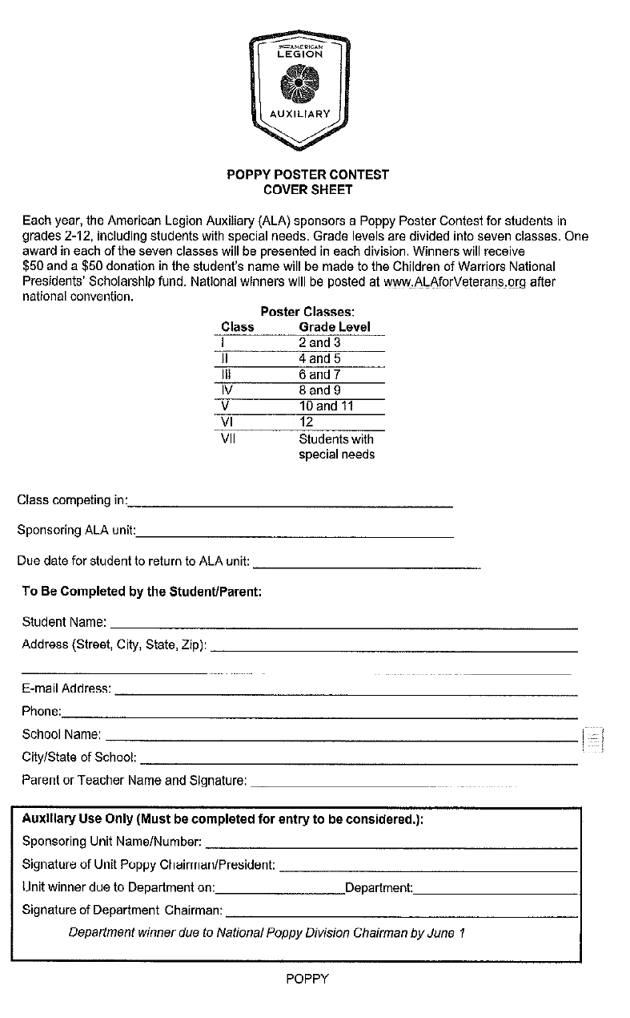
Public Relations

Patti Withrow Co-Chair Katie Simpkins Co-Chair
publicrelations@wvaux.org

Purpose of Public Relations

The purpose of the Public Relations Committee is to establish and maintain a positive public image of the organization by encouraging ALA members to be visible in their communities through branding and informing the public about the mission of the organization. Standing Rules #6, National Committees – Member/Organizational Support

Key Program Statements
- Spread the word about the American Legion Auxiliary: A Community of Volunteers Serving Veterans, Military, and their Families.
- Encourage ALA members to be visible in their communities through valuable, distinct branding.
- Share the latest news from ALA volunteer national leadership and ALA National Headquarters.

Be Seen! Be Heard! Be Known! Here’s How!

1. Promote ALA Programs and Events:
- Create awareness about ALA programs, including community service, veteran support initiatives, and events that benefit local communities.
- Use multiple channels to share information, such as social media, local newspapers, radio stations, newsletters, and community bulletin boards.
- Highlight ALA’s participation in national initiatives like the "Be the One" campaign, emphasizing the role of the Auxiliary in supporting veterans and their families.
2. Engage Local Media Outlets:
- Develop and maintain a list of local media contacts, including newspapers, radio stations, and community TV channels.
- Send press releases to local media outlets before and after major events, such
- as fundraisers, community service projects, and commemorative ceremonies.
- Offer to write guest articles or columns for local newspapers to share information about the ALA’s mission and activities.
- Invite local reporters and media representatives to attend ALA events, encouraging coverage of activities that highlight the positive impact of the ALA.
3. Utilize Social Media Effectively:
- Create or maintain unit social media accounts (such as Facebook, Instagram, and Twitter) to share updates, photos, and stories about ALA activities.
- Develop a social media calendar to schedule regular posts, including upcoming events, member spotlights, and stories of how the ALA is making a difference.
- Share content that aligns with national ALA campaigns and initiatives to ensure consistent messaging.
- Encourage members to like, share, and comment on social media posts to increase visibility and engagement.
4. Develop Promotional Materials:
- Design and distribute flyers, posters, and brochures that highlight ALA programs and events, ensuring that materials are visually appealing and clearly convey the mission of the Auxiliary.
- Create an informational pamphlet that provides an overview of the ALA, its purpose, and its impact on veterans, military families, and communities. Distribute these at local events and in community centers.
- Utilize digital design tools like Canva to create eye-catching graphics and infographics for social media and newsletters.
- Ensure that all materials are aligned with ALA branding guidelines and include the ALA logo and mission statement.
5. Strengthen Community Partnerships:
- Partner with other community organizations such as schools, veterans' groups, and local businesses to co-host events or participate in community activities.
- Collaborate with local American Legion posts to increase visibility and support joint initiatives.
- Participate in community fairs, parades, and other public events where ALA members can set up information booths, hand out promotional materials, and engage with potential new members.
- Recognize and highlight local businesses and community partners that support ALA initiatives in newsletters, social media, and press releases.
6. Create Member Spotlights and Testimonials:
- Highlight the stories of ALA members through "Member Spotlights" in newsletters, on social media, and during meetings.
- Gather testimonials from members about why they joined the ALA, what the organization means to them, and how they’ve made a difference in their community.
- Share stories that emphasize the impact of the ALA on veterans, military families, and local communities to create a personal connection with potential new members and supporters.

Mid-Year and Annual Reporting
- Mid-Year Report (Due December 1, 2025): The mid-year report should include a summary of PR activities, media coverage, social media engagement, and promotional materials created. Highlight any successful partnerships or significant increases in community awareness.
- Year-End Report (Due April 15, 2026): The year-end report should provide a comprehensive review of the unit’s PR efforts throughout the year. Include data such as social media metrics, the number of press releases sent, media mentions, and the impact of community events.
- Reports can be submitted by mail or email, and the contact information for the department’s PR Chairperson is provided on the front page of this plan and on report forms.
- These reports help the department assess the effectiveness of PR efforts and identify areas for improvement.

Key Resources for Public Relations Success
- Press Release Templates: Templates for press releases can be found on the ALA website or obtained from the department’s PR Chairperson. These can be customized for each event or announcement.
- Social Media Best Practices: Guides on effective social media use, including post frequency, best times to post, and content ideas, are available on the ALA’s website.
- Graphics and Branding Tools: Access ALA’s branding guidelines, logos, and graphic resources to ensure all materials maintain a consistent look and feel.

Final Thoughts
Public relations is a vital tool for promoting the mission and activities of the American Legion Auxiliary. Through strategic communication, engagement with local media, and effective use of social media, the PR Chairperson can help elevate the visibility of the ALA in the community. By telling our story and sharing our impact, we can attract new members, increase support for our programs, and continue to make a difference in the lives of veterans, military families, and our communities. By working together, we can ensure that the WVALA’s story is heard and that our organization continues to grow and thrive. Let’s Go WV!

Department Award:
Unit Press books: Cash award given to the best Unit Press book:
Seniors: Membership 10 - 150
Seniors: Membership 151 and over
1. Material must be prepared in a Press book no larger than 12 x 15".
2. The first page of the entry must include the name & address of the Unit Chairman, name & number of Unit.
3. The entry must include a completed copy of the Unit’s Annual Report Form.
4. The entry must include a narrative report not to exceed 1000 words. This report should describe how the public relations program was promoted in the Unit and make references to the newspaper clippings included in the press book.
5. Newspaper articles must include the name of newspaper, date, page number at the top of each article.
6. Photostat copies MAY be used, but cannot exceed 1/3 of the total articles included in the press book.
7. Newspaper articles and photographs concerning an American Legion Auxiliary and/or Legion Family
functions/programs should be included in chronological order.
Press book must be picked up at Department Convention.
Guidelines for judging are:
**Narrative 30 points
**Content of Press 25 points
**Coverage of Programs 25 points
**Overall Appearance 20 points
100 points total
Submit your Press Books for judging at the Department Convention on July 10, 2026, no later than 9:00 pm.

Department Public Relations Plaques: Best overall end-of-year report.
Helen Kessler Plaque Membership 10 - 150
Dianne McClung Plaque Membership 151 and over

Unit President Award for Quality of Leadership

Kim Mellie
president@wvaux.org

Unit President’s Plaques: An Award to the Unit President who submits the best overall End-of-Year report.
Tallulah Simpson Plaque Membership 10 - 150
Jerri Ritenour Membership 151 and over

Rules are:
- Must complete the Unit President’s End-of-Year Report.
- Must be in narrative form and may be accompanied by clippings, scrapbook, or anything she wishes to send that demonstrates her year as Unit President and what Unit has accomplished with her leadership.
- Must include a cover sheet centered with the report, name and name of the Unit, Unit Presidents Name and total membership in Unit.
- Due by EMAIL by April 15, 2026.

National Award
National President's Award for Excellence
Criteria and Details:
- Mission Outreach Programs:
- Americanism, Children and Youth, Community Service, Education, Juniors, Legislative, National Security, Poppy, V A & R.
- Your UNIT can win this award by highlighting the amazing work accomplished while working at least two (2) of our Mission Outreach Programs with a maximum of five (5) Unit winners.
- Your DEPARTMENT can win this award by highlighting the awesome work accomplished while working up to four (4) of our Mission Outreach Programs and the National Security program with special emphasis on POW/MIA Awareness, with a maximum of One (1) Department winner.
- FORM: ALA National Award and Report Cover Sheet – this standardized award/report entry sheet can be used for all Unit and Department awards. Please note the two difference sections on the form (Units or Departments) and use only the Unit or Department section.
- Indicate on the form that you are applying for the National President’s Award for Excellence.

Veterans Affairs and Rehabilitation Program

Lisa Cadwallader, NEC, PDP
var@wvaux.org

Purpose: The purpose of the Veterans Affairs & Rehabilitation Committee is to promote programs and services that assist and enhance the lives of veterans and their families, ensuring restoration and/or transition to normally functioning lives. Standing Rules #6, Core National Standing Committees

WHAT YOU AND YOUR UNIT CAN DO
Here are some ideas:
- Caregiver support: keep track of all your hours for non-family veterans. For family veteran members who you are not receiving professional compensation, track 5 hours a week if they do not live with you, 10 hours a week if they do live with you.
- Check with your local Hospital to see what they need for the homeless veterans. If you crochet or knit, make throws, hats, gloves, etc. or Blessing bags
- Host or volunteer at homeless veterans’ stand downs and events where homeless veterans receive free goods and services.
- Donate clothing, especially coats and shoes with winter coming up.
- Purchase or download the ALA Guide for Volunteers.
- Host VAMC Bingo Games and other activities.
- Donate and/or help at the VA Gift Shops (these are held in December) or other activities held at the VAMC, such as baby showers, comfort drive, and more.
- Report your Service to Veterans and Hospital Bars monthly to your Unit Chairperson who then turns in a report to the Department Chairman in April for their report.
- Contribute to the Creative Arts Festival or The American Legion Operation Comfort Warriors.
- Have your local VAMC Facility Volunteer Services submit a member for “Volunteer of the Year”. Two awards will be given out at National Convention: One for Male Volunteer and One for Female Volunteer.
- Help Veterans within your local Post or community. Ideas include but not limited to mowing, shoveling, shopping, doctor appointments, pay a bill
- Provide for Veterans and their family. Ideas include meals, paying a bill, school supplies, and Holiday baskets.
- Donate to or volunteer at a Fisher House or any Veteran-based organization or Veterans in Nursing Homes or Assisted Living
- Support veteran programs, such as wreaths across America, honor flight, & comfort warriors to name a few
- Help The American Legion, State Department of Veterans Affairs and Chamber of Commerce promote job fairs for veterans and their families.
- Volunteer in Veterans Cemeteries, place wreaths or flags on Veterans graves
- Donate or help at the VA with baby shower
- Buddy Baskets, as a welcome home, or furniture for those transitioning from a VA to a new home.
- Donate to VA items that benefit Veterans, coupons for hair cuts, canteen books, gas cards, craft supplies etc.
- Quilts of Valor
- Bubby Checks
- Welcome Home or Send off events for Troops
- Care packages to troops
- School supplies for military kids, deliver to Guard Units or Bases
What can Poppy funds be used for:
- The welfare of the families of veterans.
- The rehabilitation of hospitalized military service personnel returning home and awaiting discharge who require treatment in service hospitals.
- The welfare of veterans, active military personnel, and the families of veterans and active military personnel where financial and medical need is evident.
- Purchase of poppy kits and supplies used to make symbolic poppies and poppy items.
- Honor Flights

Year-end reporting: Emailed to chairs no later than April 15, 2026. Report forms, narrative, list of Volunteer name and hours by VA or Service to Veterans, and JPEG action pictures. Provide description of each picture. If you list of hours has more than 5 people, please email the file. Email pictures with description.
National Awards, must include a National Cover Sheet
Unit Award: Most Outstanding VA&R Program (per division)
Department Award: Best Department VA&R Program (per division)

Department VA & R Awards & Plaques:
A one-time pin will be awarded after 50 hours of Service to Veterans.
A one-time pin will be awarded after 50 hours of VAMC Hospital Service.
Hour bars for both are awarded as stated in the Volunteer Guide.

VAMC Hospital Service:
Betty Burton Plaque Membership 10 - 150
Anna Jane Williams Plaque Membership 151 and over

Service to Veterans Plaque (formerly Field Service):
Joyce Seamonds Plaque Membership 10 - 150
Paulette Anderson Plaque Membership 151 and over

WISH LIST FOR HOMELESS AND ANGEL TREE

Bath Towels Wash Cloths Deodorant
Pots/Pans Dishes Silverware
Kitchen Garbage Can Dish Towels Coffee Pot
Dish Soap Toaster Garbage Bags
Laundry Detergent Laundry Basket Bathroom Set
Shower Curtain & Hooks Bar Soap or 3 in 1 soap Razors/Shave Gel
Men’s Boxers/Boxer Briefs Men’s Jeans Men’s Socks
Men’s & Women’s Boots/Tennis Shoes Men’s & Women’s Winter Coats Plates/Bowls
Men’s & Women’s T-Shirts Cups Toilet Paper
Paper Towels Cooking Utensils Mop/Broom/Dustpan
Pillows Can Opener Bed in a Bag
Men’s Belt Bathroom Garbage Can Shampoo/Conditioner
Dish Racks Microwave First Aid Kit
Women’s Jeans Women’s Underwear Blow-up Mattress
Duct Tape Black Trash Bags Flashlights
Men’s Long Sleeve Shirts Cleaning Supplies
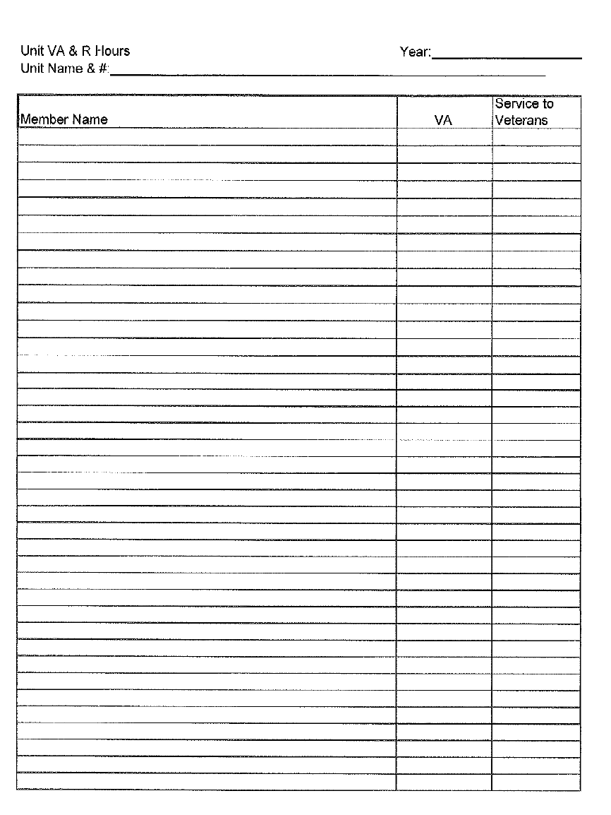
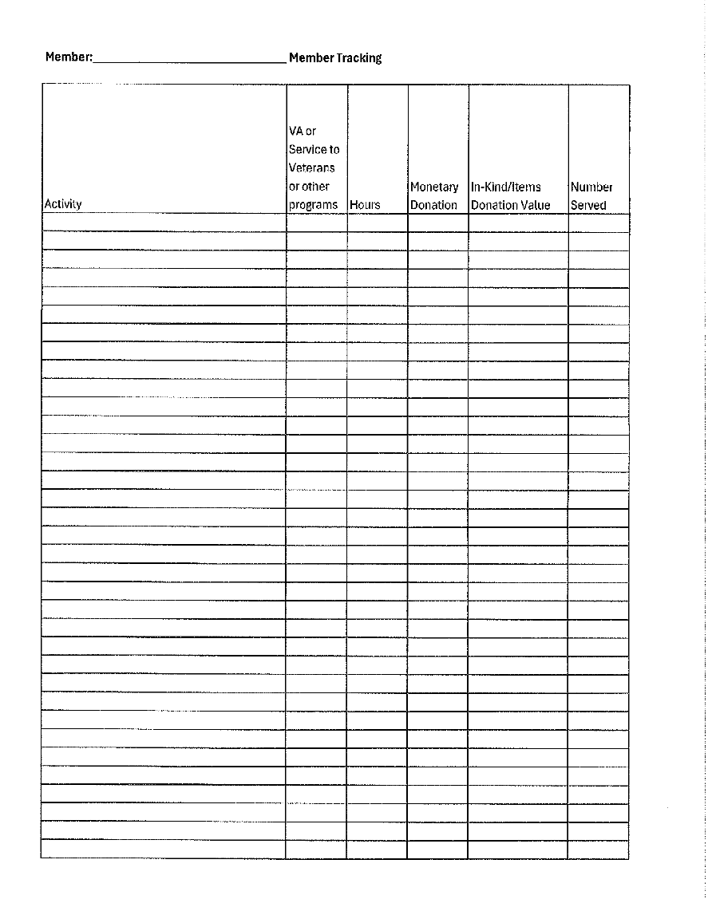
Scrapbook

Margaret Yost
PO Box 36
Gypsy WV 26361
304-629-0688
mdyost2010@gmail.com

Mission: Unit Scrapbook should document the work of the members of your Unit toward the American Legion Auxiliary Programs. Community and social events as well as volunteer work over the course of the year should also be included.
The scrapbook is a visual history of your Unit/District/Department Activities for the current administrative year. It is an opportunity for the Scrapbook Chairman to illustrate the year’s activities with pictures, newspaper articles and memorabilia that have been collected throughout the year.

Scrapbooks are to be taken to the Department Convention by July 9, 2026 no later than 9:00 pm for judging.

Scrapbook Guidelines
Size: Scrapbooks can be any size.
Cover: All covers must have the Auxiliary Emblem.
Title Sheet: Unit name and number, and District Number must be displayed on this page. If it is a Junior Auxiliary Scrapbook, please have that indicated on this page as well, chairman submitting the scrapbook and the number of members in the Unit.
Decorations: with the wealth of craft material available now, you can create all kinds of beautifully decorated scrapbooks. (Points in judging are given for neatness, originality, and presentation.)
Contents: should be arranged according to months, starting in July and ending with June. Newspaper articles, programs, favors, newsletters, pictures, etc. can be included in the scrapbook. Do not make the book so thick it will not close properly.
Once your scrapbook has been judged, it is your Unit’s responsibility to pick up the scrapbook. None will be mailed to Unit.

Cash Award will be presented to winning Senior Scrapbook in two categories. 1) 10 - 150
2) 151 and over

Traveling Scrapbook Plaques
Junior: Casey Michael Traveling Plaque Membership 10-150
Charli Michael Traveling Plaque Membership 151 & over
Senior: Savanna Kauffman Traveling Plaque Membership 10-150
Debbie Michael Traveling Plaque Membership 151 & over

Basis of Judging Scrapbook

Neatness, Originality and presentation -------------------------------------------------------- 40%
Design an appealing page
All material should be placed in chronological order
Articles & pictures should appear by monthly order
Material in scrapbook should be attractively spaced in a neat orderly fashion & clean.
The inside pages should not overlap the edges of the outside cover.
Newspaper material ( Publicity on programs) ------------------------------------------------ 20%
Newspaper articles must include caption, name of paper and date Pictures -------------- 20%
Pictures must have caption. Group Pictures together with a brief description stating
name of the activity or project.
Programs, souvenirs, mementos of various events ----------------------------------------- 20%
Thank you cards, letters acknowledging participation in events, etc.
________
Total 100%

Total Participation
Kim Mellie
president@wvaux.org

To be eligible for the award for Total Participation, your Year-End report must meet the following criteria:

- The unit must have participated in ALL PROGRAMS for this administrative year (2022-2023).
- Cover Sheet with the name of Unit, Number of Unit, Location of Unit, and President’s name.
- Narrative report not more than 500 words describing the activities your Unit participated in.
- Send directly to the Department President no later than June 1, 2026.

Total Participation Plaques: To be given to the Unit submitting the best narrative report in all programs of the American Legion Auxiliary.
Ina Polsinelli Plaque Membership 10 - 150
Jessica Payne Plaque Membership 151 and over

Cash Awards
As per Standing Rules and Department Budget

Scrapbook------ Seniors (10-150) $5.00 (151 and over) $5.00 Juniors $2.50

History-- Seniors (10-150) $10.00 (151 and over) $10.00 Juniors $2.50

Poppy Poster Award---Each of the seven classes of will receive $5.00

Prayer Book--- Seniors (10-150) $5.00 (151 and over) $5.00

Public Relations—Seniors (10-150) $5.00 (151 and over) $5.00

Timeless Award—Past President’s Luncheon Ticket

Membership Cash Awards:

Cash Award: First Unit to reach Goal in each Class
Class I Membership 10-25
Class II Membership 26-50
Class III Membership 51-100
Class IV Membership 101-200
Class V Membership 201 and over

Cash Award: First District to Reach Goal
First Unit to Reach Goal
Unit that enrolls most NEW Senior members
Unit that enrolls most NEW Junior members
District that organizes a NEW Unit
Unit in each District with the most NEW members

Units must have all Mandatory Funds paid 30 days prior to Department Convention and have attended Fall or Spring conferences in their District to be Eligible for Membership Awards.

Membership totals are based on membership in Department Headquarters 30 days prior to the Department Convention.

For National Forms:
Go to www.alaforveterans.org, log in under Member Log In, type National Awards in the search box and enter or click on the magnifying glass. Click on Awards and then click on the blue “Awards Applications” box. This page lists the awards, forms, applications, etc. Click on National Awards Form and it shows the Programs/Committees you can submit for an award at the bottom of the form (https://www.legion-aux.org/National-Awards-Form).

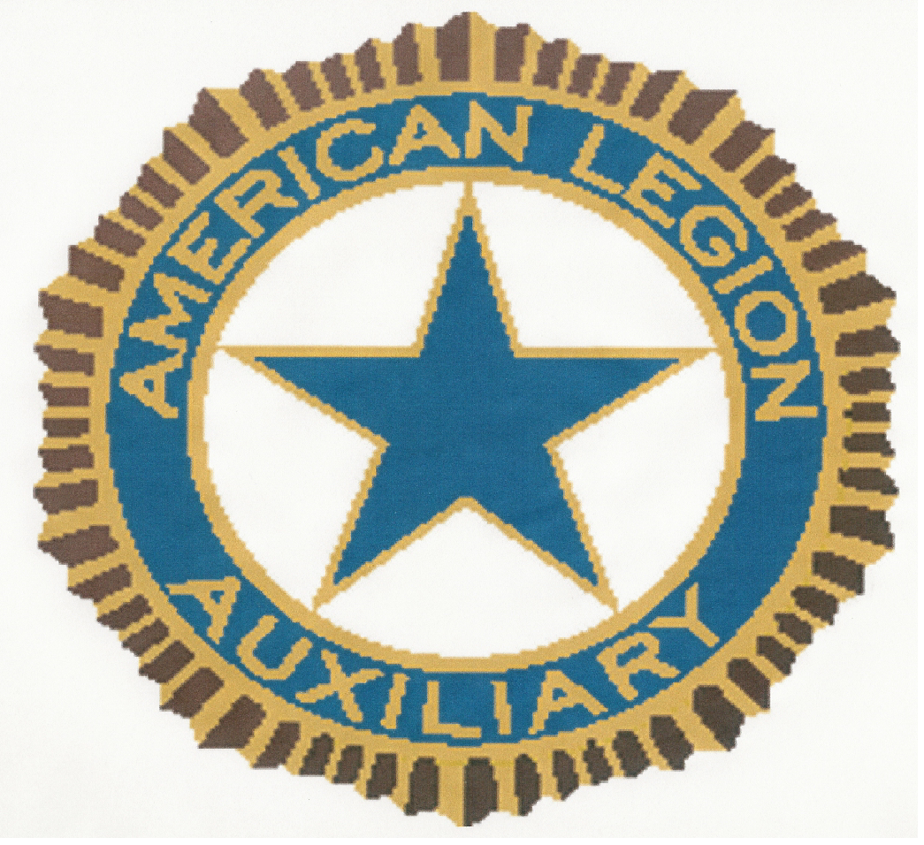
AMERICANISM ESSAY CONTEST
2025 Cover Sheet

Each year, the American Legion Auxiliary (ALA) sponsors an Americanism Assay Contest for students in grades 3-12, including students with special needs. Grade levels are divided into six classes. One award in each of the six classes will be presented in each division. Winners will receive $50 and a $50 donation in the student’s name will be made to the Children of Warriors National Presidents’ Scholarship fund. National winners will be posted at www.ALAforVeterans.org.

Essay Title: “What Does America the Beautiful Mean To Me (regarding veterans and our military)?”

Essay Classes: _____________________________________________________________
Class Grade Level Word Requirement
I 3 and 4 150-250
II 5 and 6 250-300
III 7 and 8 350-400
IV 9 and 10 450-500
V 11 and 12 450-500
VI Students with Word count should
Special needs correspond with students
grade level

Essay Checklist:
__ Class competing in ______
__ Sponsoring ALA Unit _______
__ Typed or neatly written essay conforming to the word requirement for class
__ Completed essay coversheet as first page of essay
__ Word count of essay ______
__ Due date for student to return to ALA Unit ____________

To Be Completed by the Student/Parent:

Student Name: _____________________________________________________________________________________

Address (Street, City, and Zip): ________________________________________________________________________

__________________________________________________________________________________________________

E-mail Address: _____________________________________________________________________________________

Phone: ____________________________________________________________________________________________

School Name: ______________________________________________________________________________________

School City/Name: __________________________________________________________________________________

Teacher Name and Signature: __________________________________________________________________________

American Legion Auxiliary
MEMBER Year-End Impact Numbers Report

I am a member of Unit # Unit Name
Department
My name
Here is what I did in the past 12 months since May 1.

- My ALA Service for Veterans/Active-Duty/Reserve Military (Examples: hours shopping for and preparing care packages for deployed troops, helping wounded warriors and elderly veterans at home, providing transportation, military send-off and welcome-home events, parades, projects for homeless veterans, activities related to distributing poppies, recording veteran histories, raising money for the Veterans Creative Arts Festival, fundraising events that benefit veterans (such as Walk, Run & Roll), assisting with veterans hiring fairs, advocating for The American Legion legislative agenda that supports veterans and the military.)

Line 1 Hours I volunteered:
Line 2 Dollars I personally spent/donated: $
Line 3 Number of veterans/military I assisted:
Line 4 Number of “Veterans in Community Schools” presentations I facilitated:

- My ALA Service for Military Families: (Examples: programs for military and veterans’ children, helping Family Support Groups, supporting adopt-a-military-family projects, military spouse hiring fairs, organizing and delivering hero packs, providing childcare for military activities, distributing Blue Star Banners, providing G.I. Josh dogs)
Line 5 Hours I volunteered:
Line 6 Dollars I personally spent/donated: $
Line 7 Number of military families I served:

- My ALA Service for Youth (Examples: Jr. Activities, classroom and patriotic activities for children, camps open to all children, raising funds for or promoting Legion Family activities like Girls State)

Line 8 Hours I volunteered for ALA Girls State:
Line 9 Hours I volunteered for all other Legion Family youth activities:
Line 10 Dollars I personally spent on goods for youth activities (parties, backpacks): $
Line 11 Direct cash aid to help a needy child: $
Line 12 Number of children/youth served:
Line 13 Dollars donated to all other child service charities (ex: Make a Wish, St. Jude’s): $

- My Service Representing the ALA in My Community (Examples: blood drives, walks/runs, food pantries)
Line 14 Total number of hours for any service not included in Sections 1 through 3:
Line 15 Total dollars spent for any service not included in Sections 1 through 3: $

When completed, send to: by / /
(Get name and date from Unit)
CONGRATULATIONS--YOU DID IT! THANK YOU FOR ALL YOU DO AND FOR REPORTING YOUR SERVICE!
American Legion Auxiliary
UNIT Year-End Impact Numbers Report

Unit # Unit Name
Department Unit President
Your Name (if other than president)
Your Email
Number of Member Impact Reports
Here is what our Unit did in the last 12 months.

- Our ALA Service for Veterans/Active-Duty/Reserve Military

 | Service for Veterans/Military | Obtain Total From | Member | Unit | Total
Line 1 | Total hours members volunteered | Member Form Line 1 |  | N/A
Line 2 | Total dollars spent | Member Form Line 2 | $ | $ | $
Line 3 | Total number of veterans/military assisted | Member Form Line 3
Line 4 | Total number of “Veterans in Community Schools” presentations facilitated | Member Form Line 4
Line 5 | Value of in-kind donations received* | Unit Records | N/A | $ | $
Line 6 | Number of poppies or poppy items distributed | Unit Records | N/A
Line 7 | Dollars raised from poppies | Unit Records | N/A | $ | $
*Estimated cash value of non-cash donations from NON-MEMBERS of goods (like paper goods, clothing) or services (like pro-bono CPA services from a local firm)

- Our ALA Service for Military Families
 | Service for Military Families | Obtain Total From | Member | Unit | Total
Line 8 | Total hours members volunteered | Member Form Line 5 |  | N/A
Line 9 | Total dollars spent | Member Form Line 6 | $ | $ | $
Line 10 | Number of military families served | Member Form Line 7

- Our ALA Service for Youth

 | Service for Children & Youth | Obtain Total From | Member | Unit | Total
Line 11 | Total hours for ALA Girls State | Member Form Line 8 |  | N/A
Line 12 | Dollars spent for ALA Girls State | Unit Records | N/A | $ | $
Line 13 | Total hours for other  Legion Family youth activities | Member Form Line 9 |  | N/A
Line 14 | Dollars spent on goods  for youth activities | Member Form Line 10 | $ | $ | $
Line 15 | Dollar amount of direct cash aid  to help a needy child | Member Form Line 11 | $ | $ | $
Line 16 | All other UNIT expenses (parties, dinners, paper goods, trophies) | Unit Records | N/A | $ | $
Line 17 | Total number of  children/youth served | Member Form Line 12
Line 18 | Donations to all other child service charities | Member Form Line 13 | $ | $ | $

- Our Service Representing the ALA in Our Community

 | For any service not included  in Sections 1-3 | Obtain Total From | Member | Unit | Total
Line 19 | Total number of hours | Member Form Line 14 |  | N/A
Line 20 | Total dollars spent | Member Form Line 15 | $ | $ | $

- Scholarships Presented/Awarded by Our Unit
 | Scholarships | Obtain from | Total
Line 21 | Number of Unit scholarships presented/awarded | Unit Records
Line 22 | Total dollar amount of Unit scholarships | Unit Records | $
Line 23 | Total dollar amount donated to  Department scholarships | Unit Records | $

When completed, send to: by / /
(Get name and date from district or county, if applicable, or Department)

CONGRATULATIONS---YOU DID IT! THANK YOU FOR ALL YOU DO
AND FOR REPORTING YOUR UNIT’S IMPA

